# Comparison model 9

## Initial temperatures

* Still some drops in temperature (minimal). Possible convergence issue.
  + Solution 1: apply a ramp to the heat input -> start over again -> discarded
  + Solution 2: refine temporal discretization. @All teams
  + Solution 3: refine resolution of outputs (enhanced writing frequency). @All teams
* Still some delayed response in CA and OGS (1-2 output times). Maybe due to frequency of writing results. Comment by Matthias: possibly due to a small mismatch on the heater’s conductivity, heat capacity and volumic mass:
  + CA: L=52W/mK; Cp=490J/kgK; rho=1200kg/m2
  + CB: L=50W/mK;Cp=490J/kgK; rho=1256kg/m2
  + OGS: L=0; Cp=0; rho=0
  + Comment by Matthias: Higher conductivity induces greater heat dissipation hence lower temperature at the beginning which may explain our slightly delayed response. The volumic mass shouldn’t have a huge impact at this scale. For OGS I would expect higher temperature since the heater is not acting as a heat sink. Maybe the use of a ramp function on the first days of heating for numerical purposes could be the cause. Is it the case? Could also be due to slight differences in the initial saturation of the GBM. Once again, the discrepancies are minimal and I think we should focus on the hydraulic part

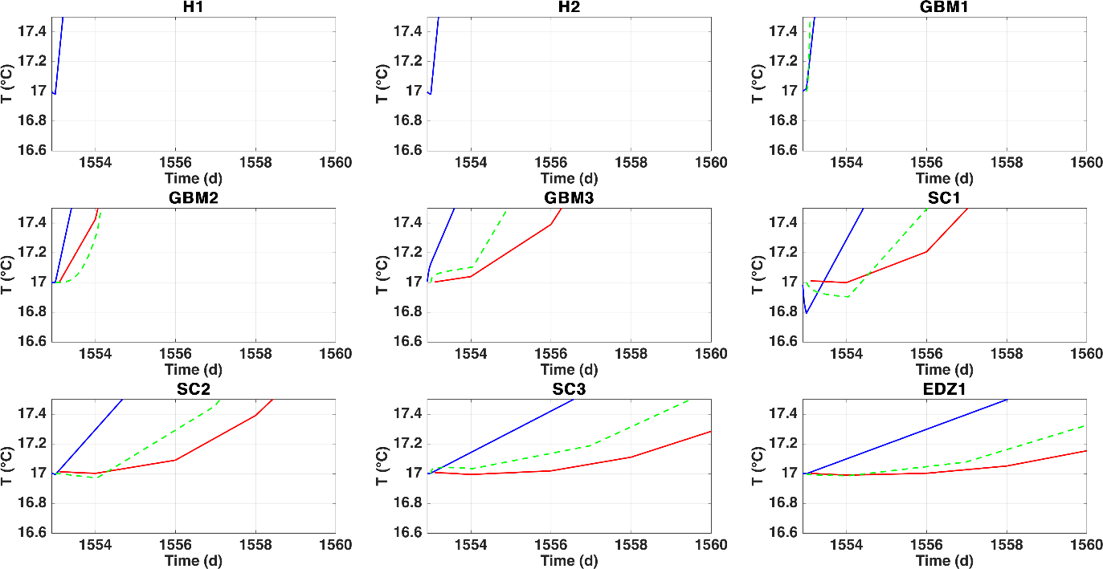

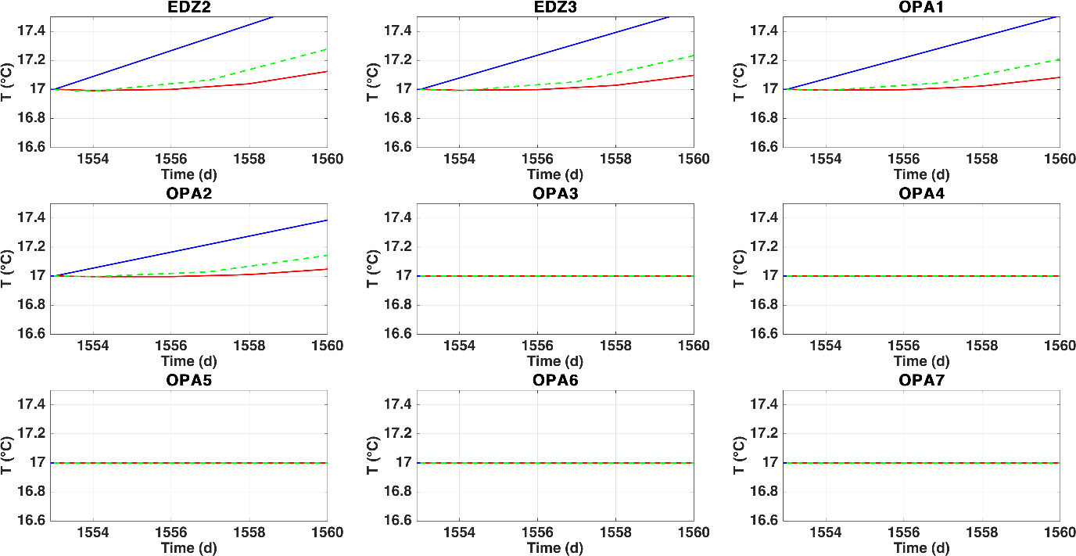

## Temporal evolution of temperature

* Still some small discrepancies at T of heaters (OGS does not provide results here).
* GBM: Large discrepancies (some 5C) between outputs at early-mid times of heating (t<3000), possibly due to the differences in T of heaters. Systematically, OGS calculates highest T, then CB, then CA
* SC: similar comments as for GBM. Notably, differences between CB and CA vanish at SC3. OGS calculates highest T
* EDZ: same comments as for SC3. CB and CA identical, OGS calculates highest T
* OPA: same comments

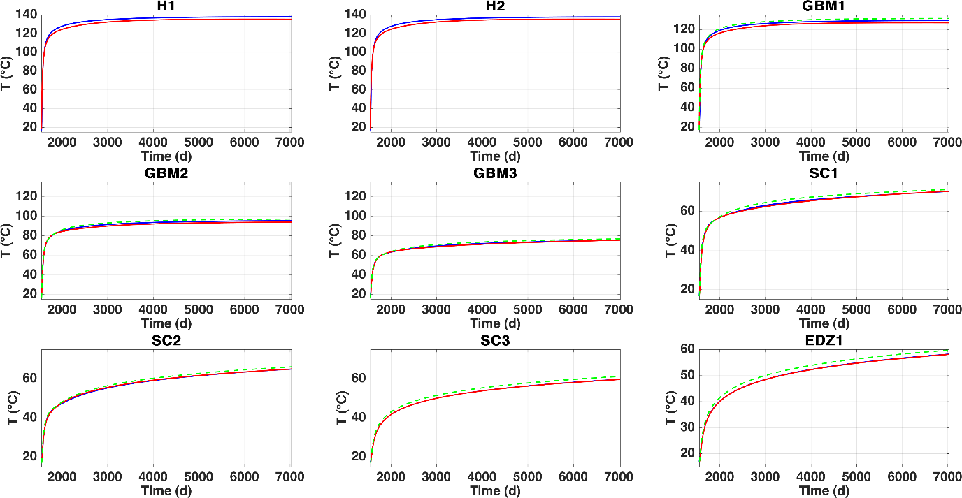

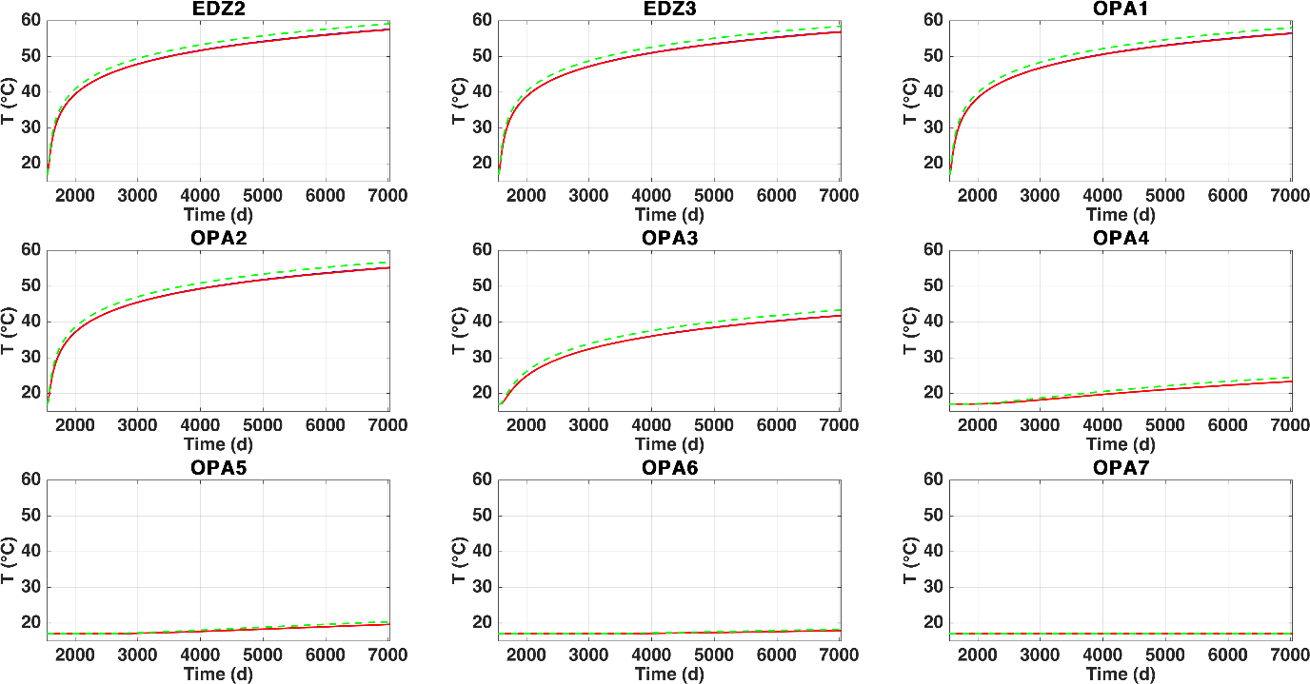

## Initial relative humidity

* Results at heaters only provided by CB
* GBM: very similar CA-OGS, smaller value by CB. @UPC: please check
* SC: very similar values; kink in SC3 by OGS?
* EDZ: please remember that CB can yield RH>100 (y axis trimmed to 100 in all cases). RH by CB always 100%, small drop by OGS, drop by CA
* OPA: CB-OGS ok at 100%. Small drop by CA at OPA1

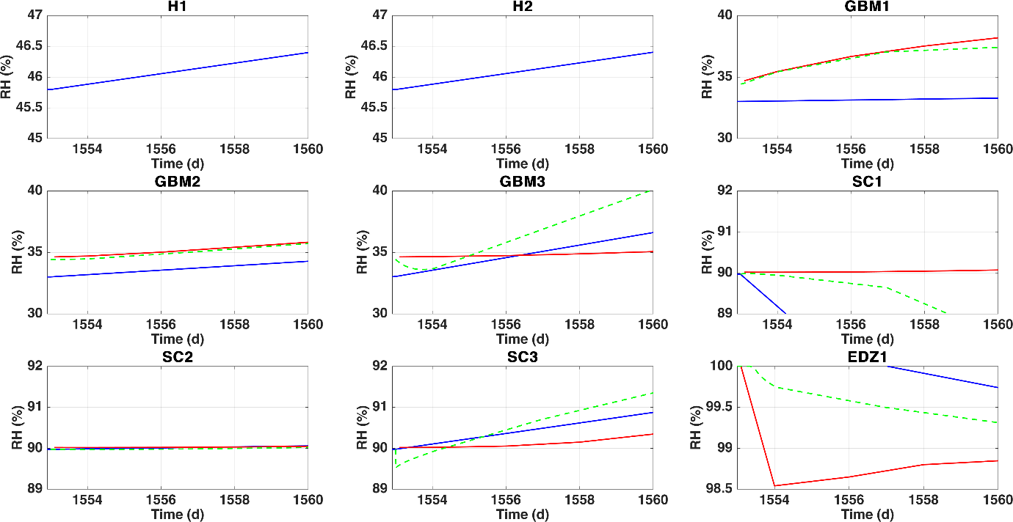

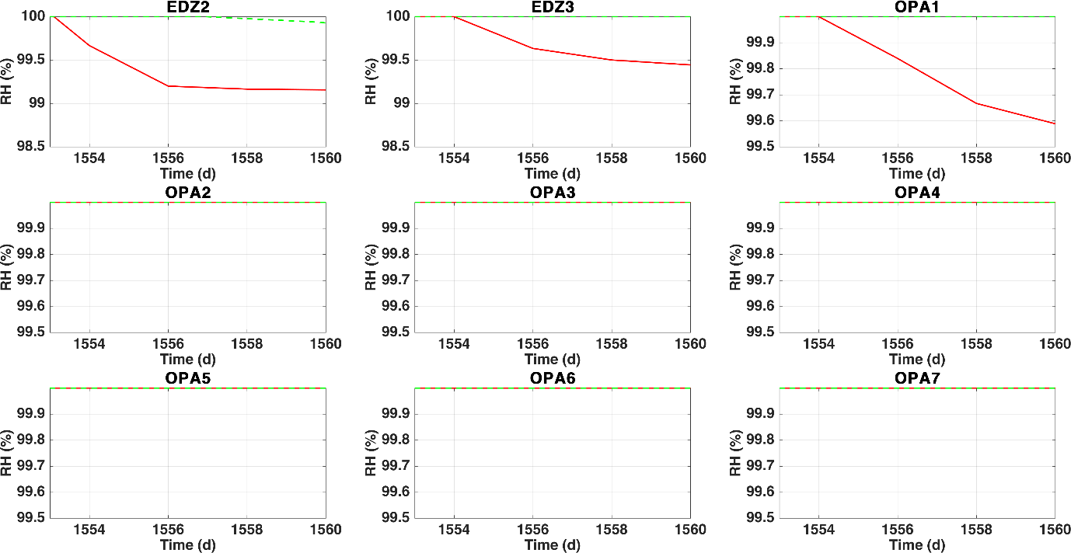

## Temporal evolution of RH

* At Heaters only CB
* GBM: Now very similar results CB-OGS, especially at GBM1 and GBM2. Different trend CA GBM3? Comment by Matthias (see also the section Comparison Diffusivity): “I’m suspecting a lower vapor diffusion for CA in the GBM that could explain the less steep decrease of the RH close to the heater. It could be interesting verify the diffusivity implementation (e.g. 3D surface plot of the diffusivity coef. As function of the temperature and gas pressure) and if we are all using the same formulation and parameters. Besides this initial problem, I’m noticing that results tend to diverge as we move toward the shotcrete. The re-saturation of the GBM and shotcrete seems different (especially for CB). Could be interesting to have a look at the shotcrete initial saturation and WRC.” See dedicated sections
* SC: Now CB-CA more similar (SC1); Kink in CA SC2?
* EDZ, OPA: very comparable results 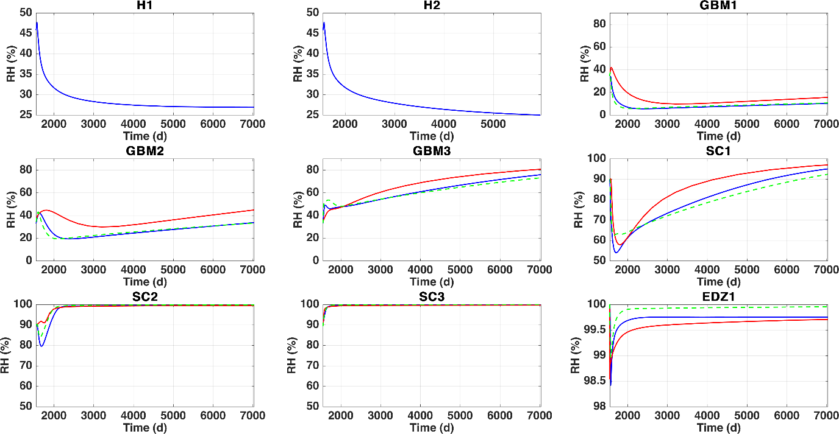

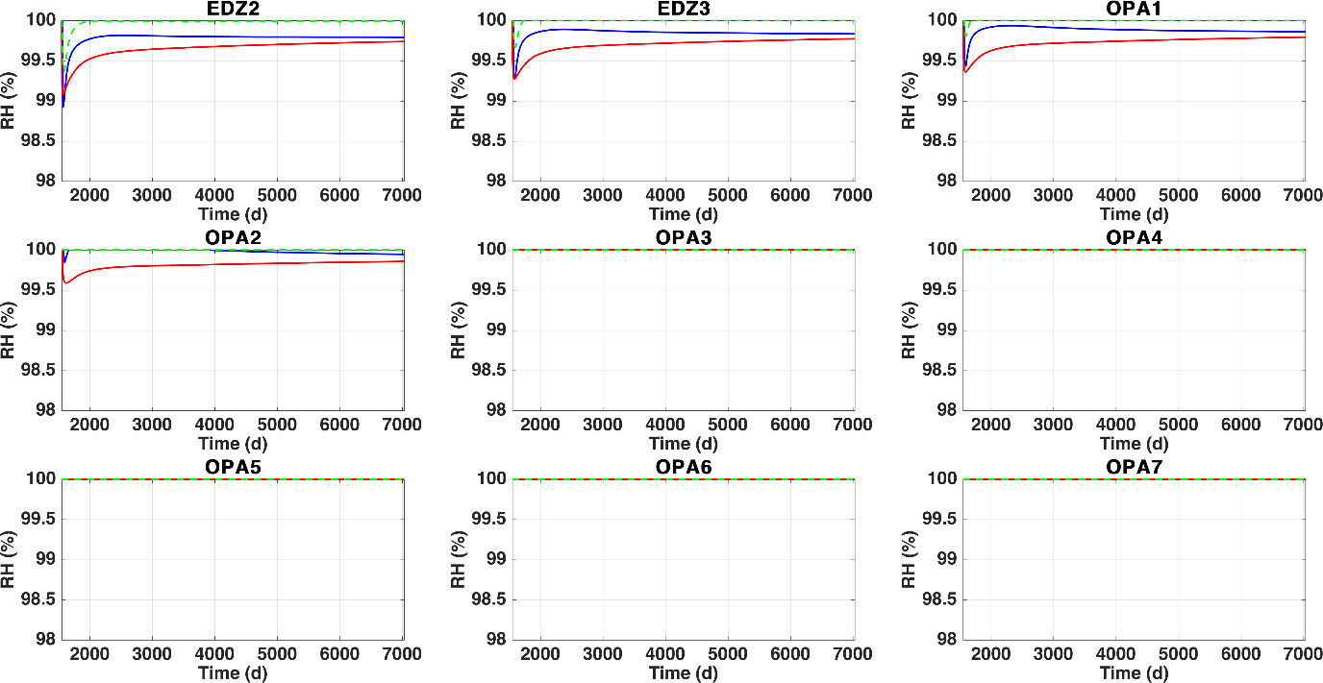

## Initial liquid pressure

* At heaters, no results by CA and OGS
* GBM: very similar initial suction by CA and OGS, slightly higher by CB (@UPC: please check); trend by OGS at GBM3 hard to explain
* SC: identical results CA-CB. Weird that OGS-SC1 and SC3 exhibit some trend, but not OGS-SC2 (some numerical instability?)
* EDZ: weird initial condition by CB (pL>2 MPa)?. CA-OGS same initial condition, but different trends (more suction by CA)
* OPA1-OPA2: similar comments. Weird initial pressure by CB in OPA1 (but ok in OPA2). Strong desaturation by CA.

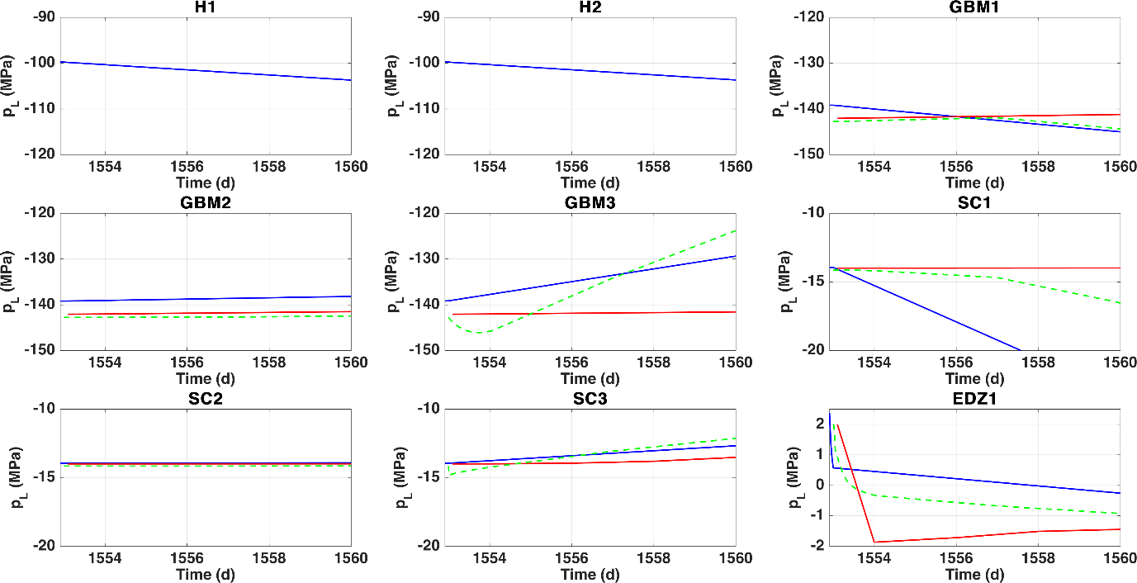

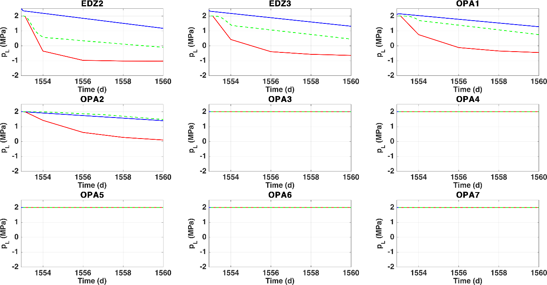

## Temporal evolution of pL

* GBM: very strong desaturation at early times by OGS, then CB, then CA. Trends similar
* SC: similar observations, CB and CA now compare well. Kink at SC2 by CA?
* EDZ-OPA: CB-CA similar. OGS calculates highest pL. Slower resaturation by CA?

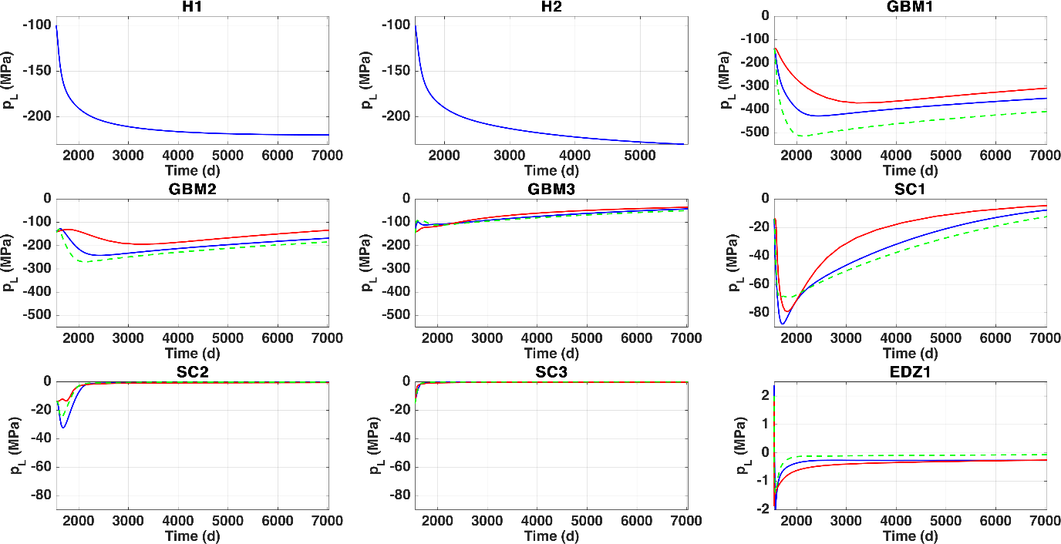

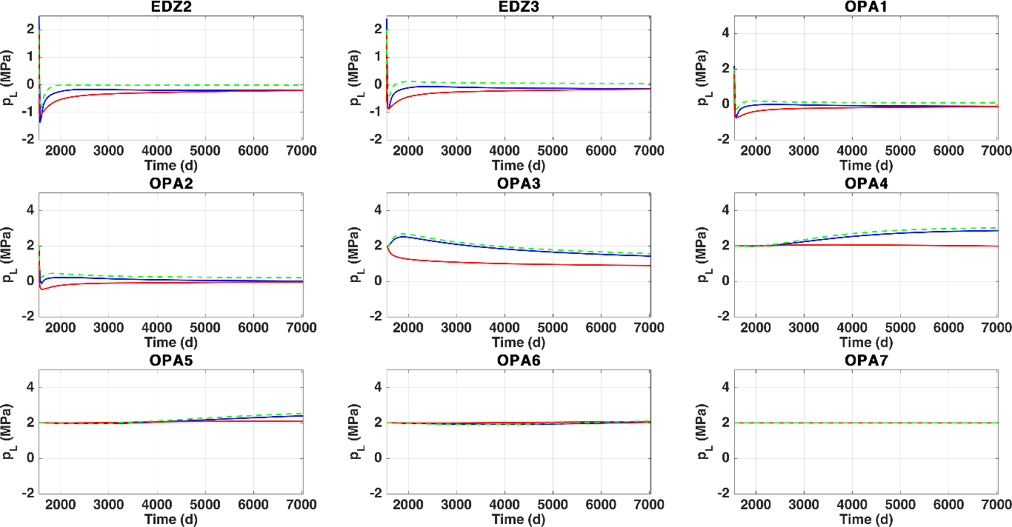

## Initial gas pressure (no results by OGS)

* Overall, very small discrepancies
* Values by CB sometimes > 0.1, sometimes < 0.1 Mpa (?)
* At GBM3 and SC, and near EDZ; initial “kink” in CB curve but linear in CA (numerical instability?)
* EDZ and near OPA: “kink down” in CA?

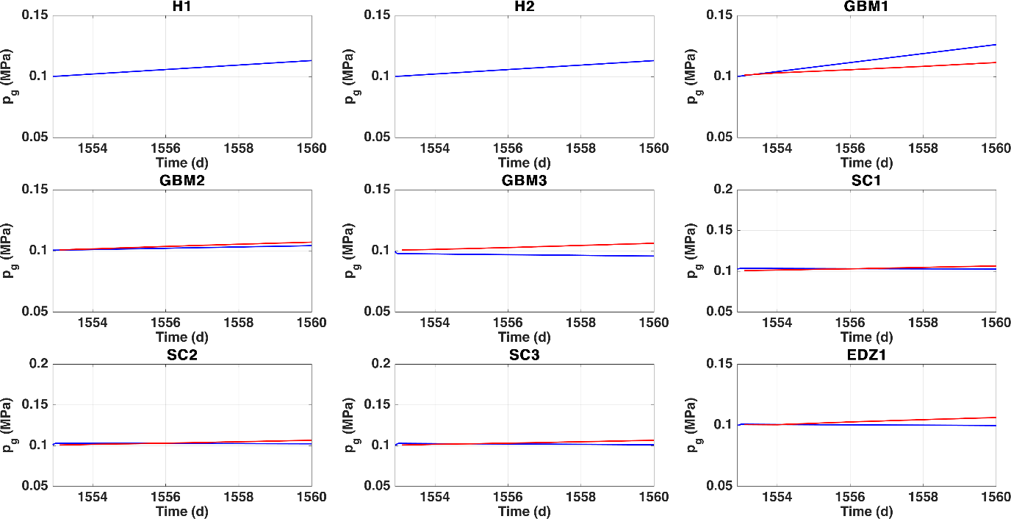

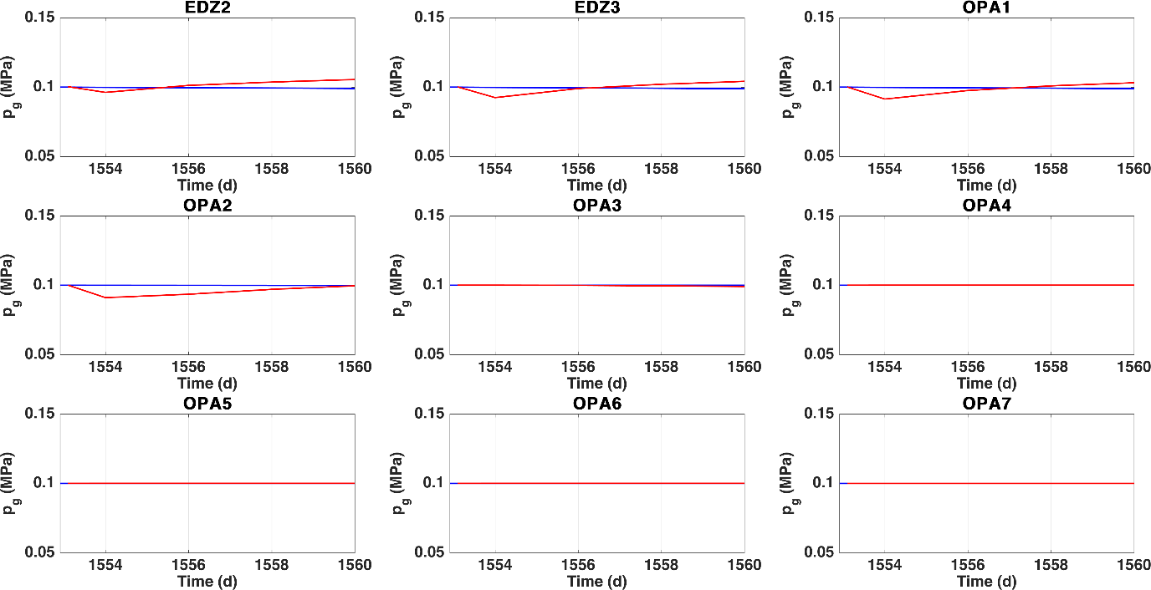

## Temporal evolution of pg (no results by OGS)

* GBM-SC Similar trends by CA-CB. Difficult to extract further conclusions (?). AT GBM3 and SC, initial “boost” by CA, but goes down in CB
* EDZ and near OPA: different trends CA increases, CB decreases (?)
* Comment by Matthias (see section on Diffusivity): I think, most of the discrepancies could be due to the same problem mentioned before, the vapor diffusivity is greater in CB than in CA.

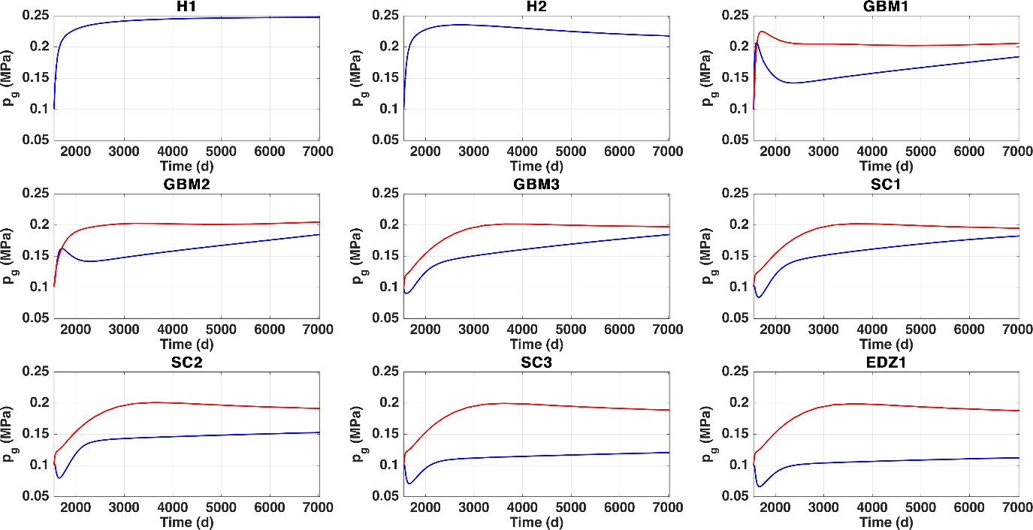

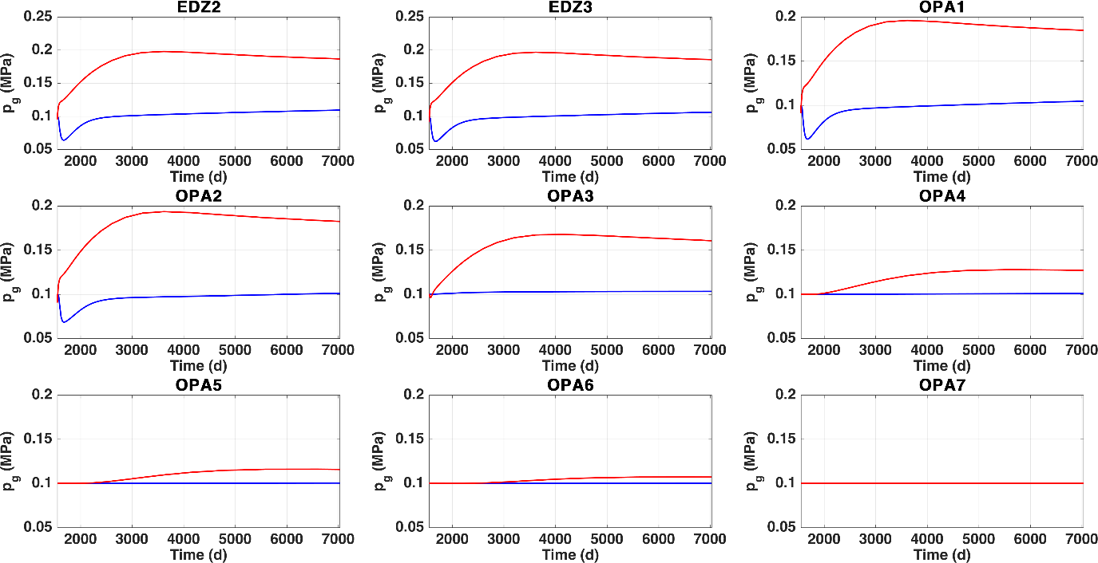

## Initial liquid saturation

* GBM: Initial saturation higher in CB (@UPC: please, check). CA constant, but CB and OGS desaturate
* SC: same comments (@UPC, please check initial saturation)
* EDZ: initial saturation apparently ok. Kink by CA?
* OPA: impact of maximum saturation quite visible in the CA case (perhaps try a slightly larger value?)

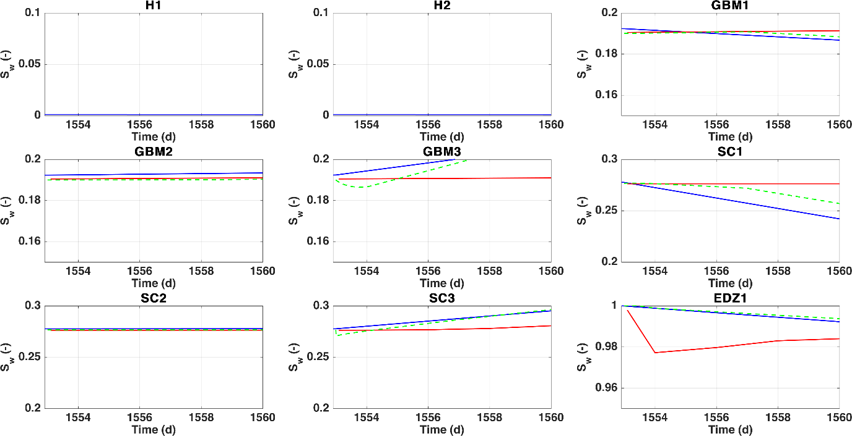

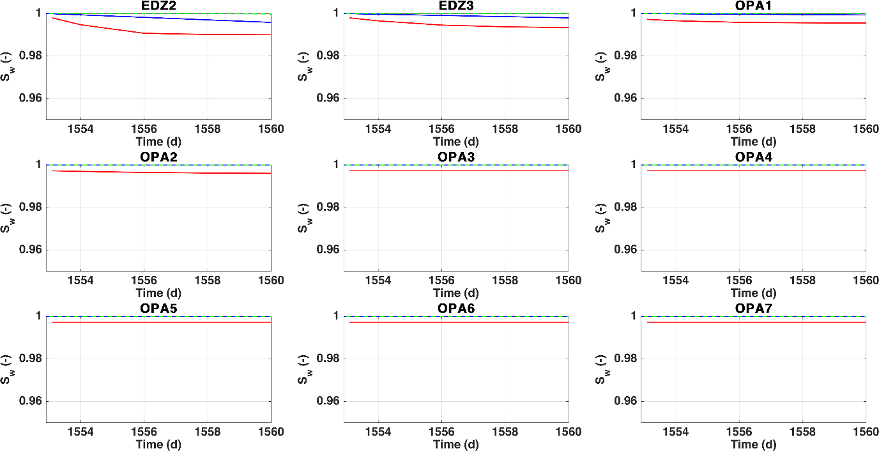

## Temporal evolution of liquid saturation

* GBM: similar trends and values OGS-CB; more saturation in CA (gas mobility?)
* Overall: trends and values OGS-CB similar for early-mid times of heating.

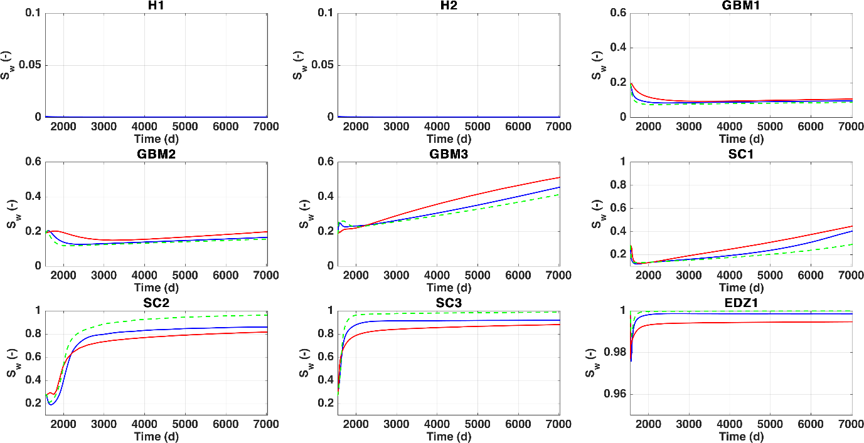

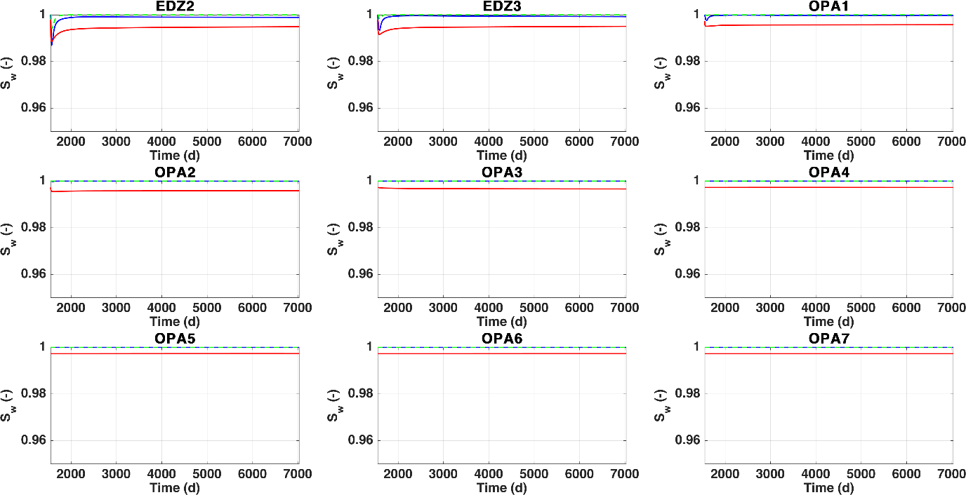

## Initial liquid density

* Very different UPC at GBM/SC (@UPC: please, check)

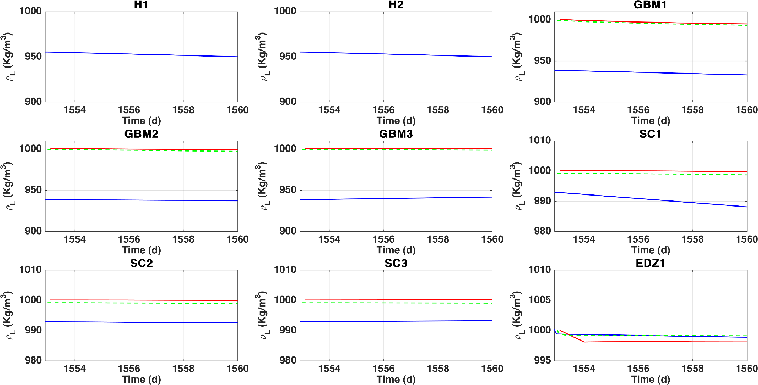

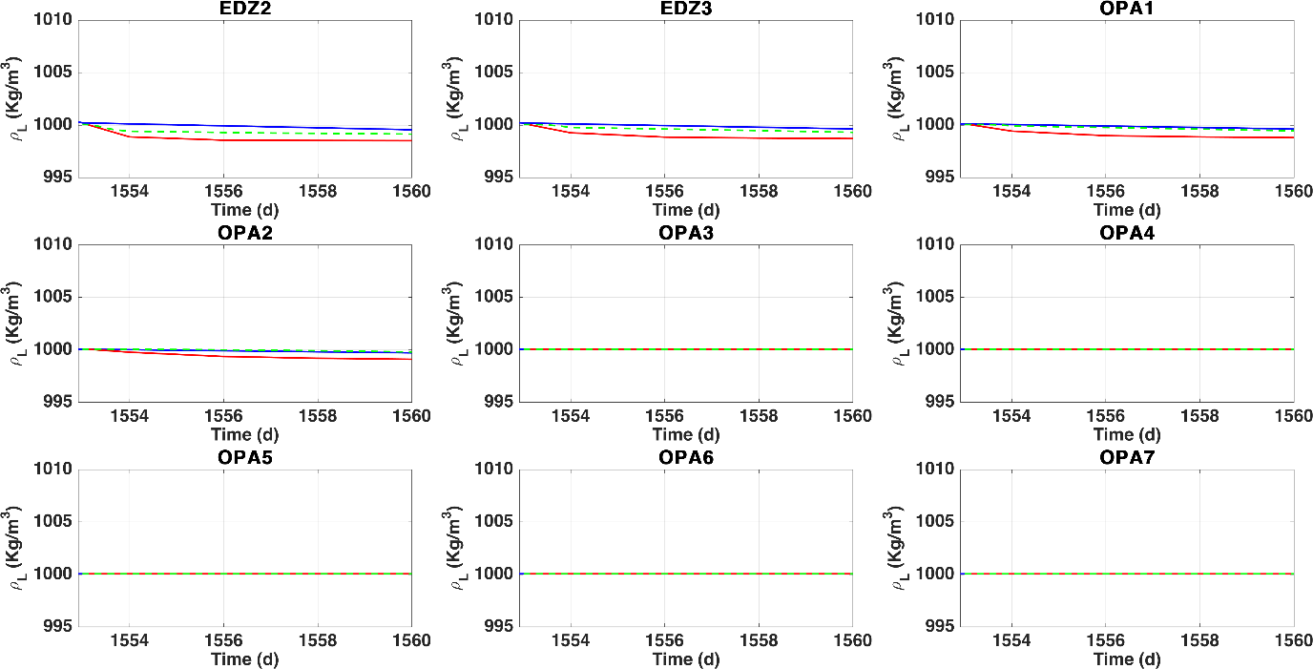

## Temporal evolution of liquid density

* Very different trends OGS (please, check)
* SC3 by CA and CB increasing?
* What happens at OPA3?

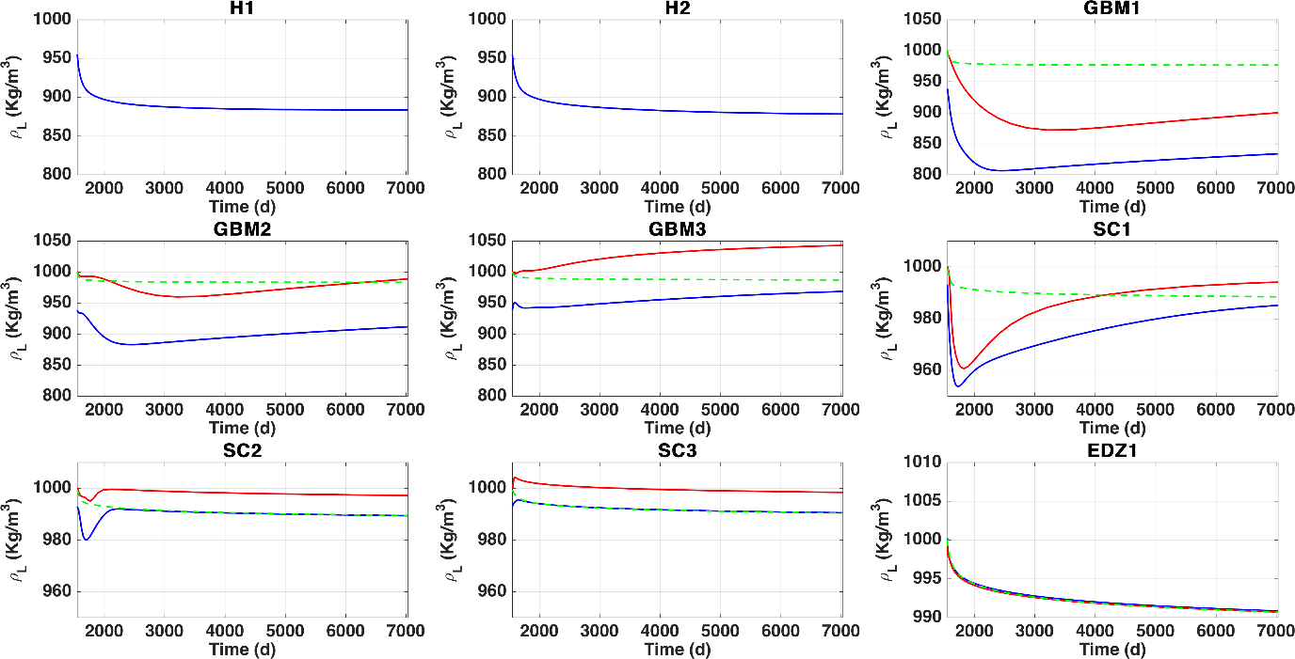

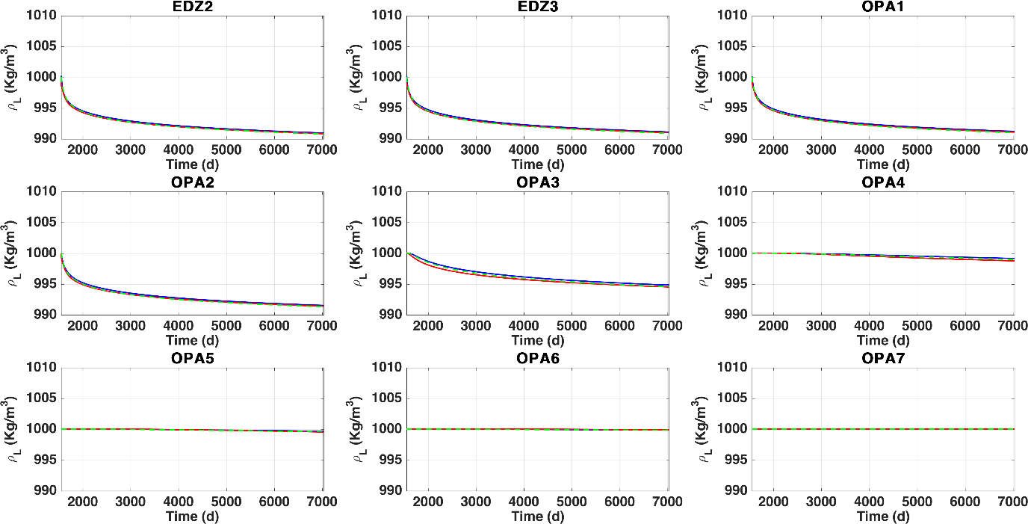

## Initial liquid viscosity

* Different initial viscosity UPC, please check

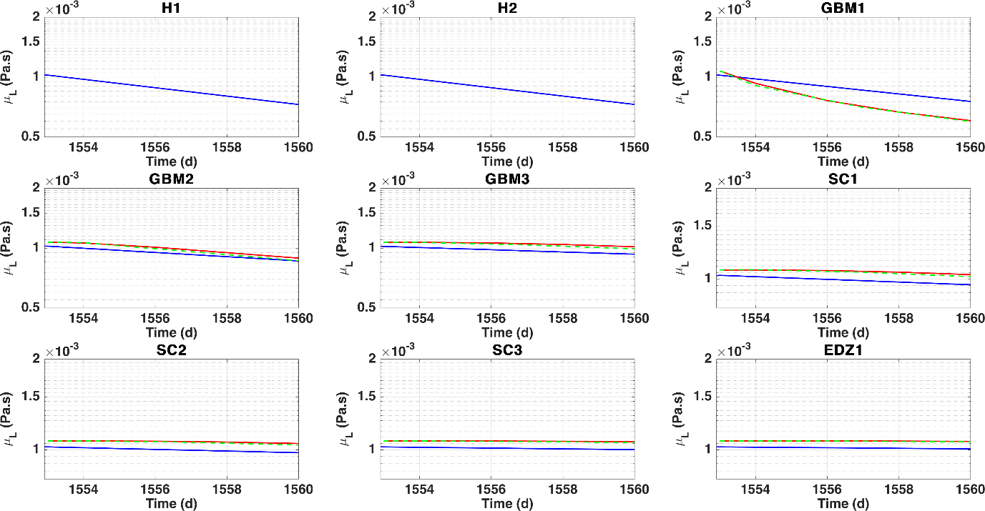

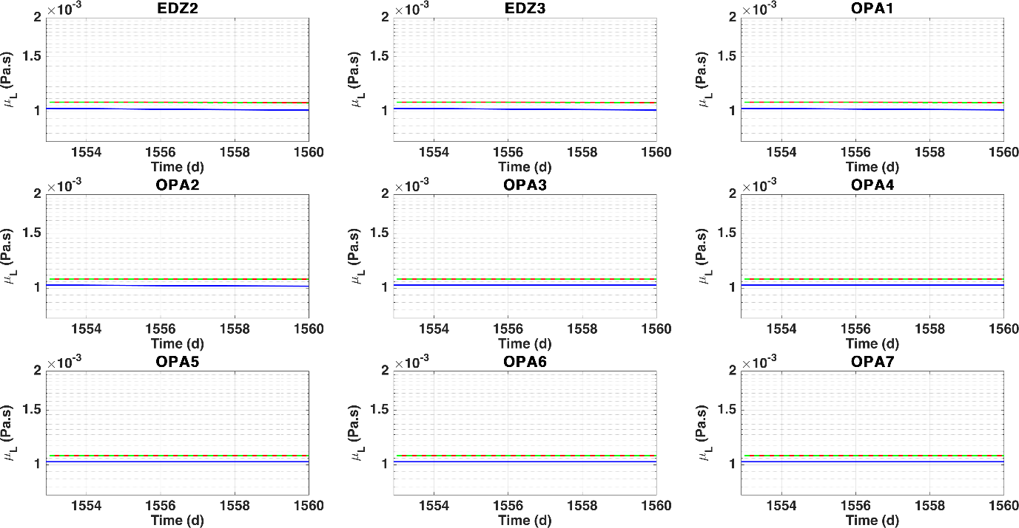

## Temporal evolution of liquid viscosity

* Overall, very similar trends and values

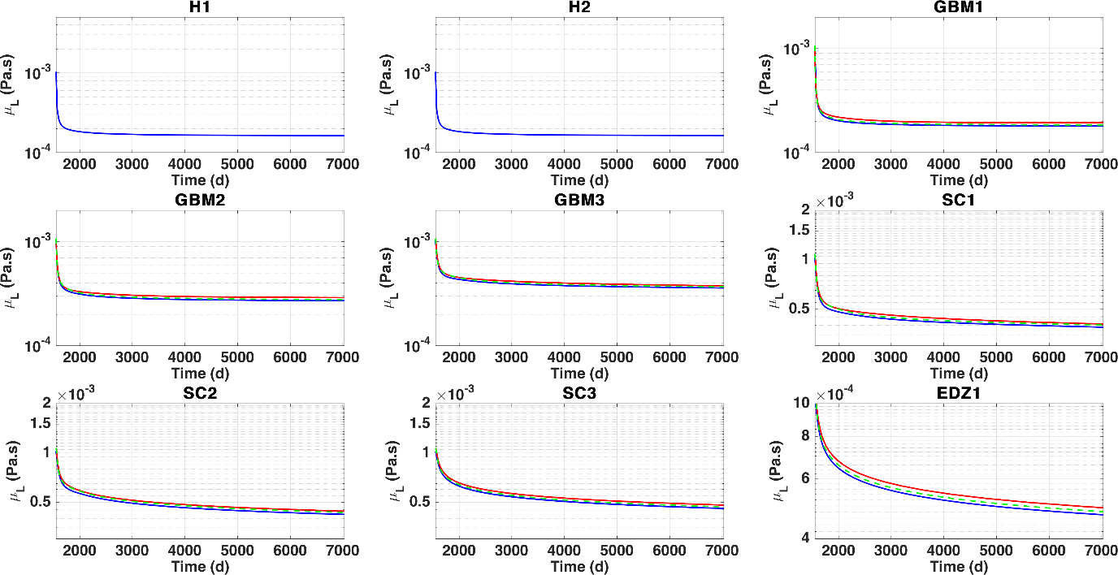

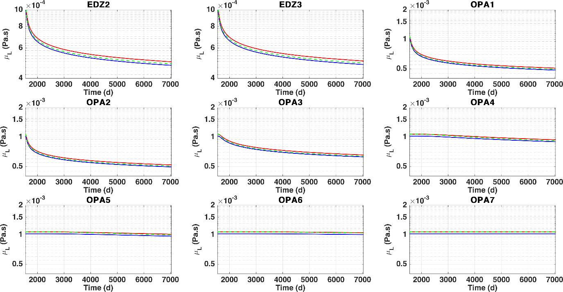

# Comparison model 10

Please, correct initial values in view of comments to model 9 outputs.

## Initial temperatures

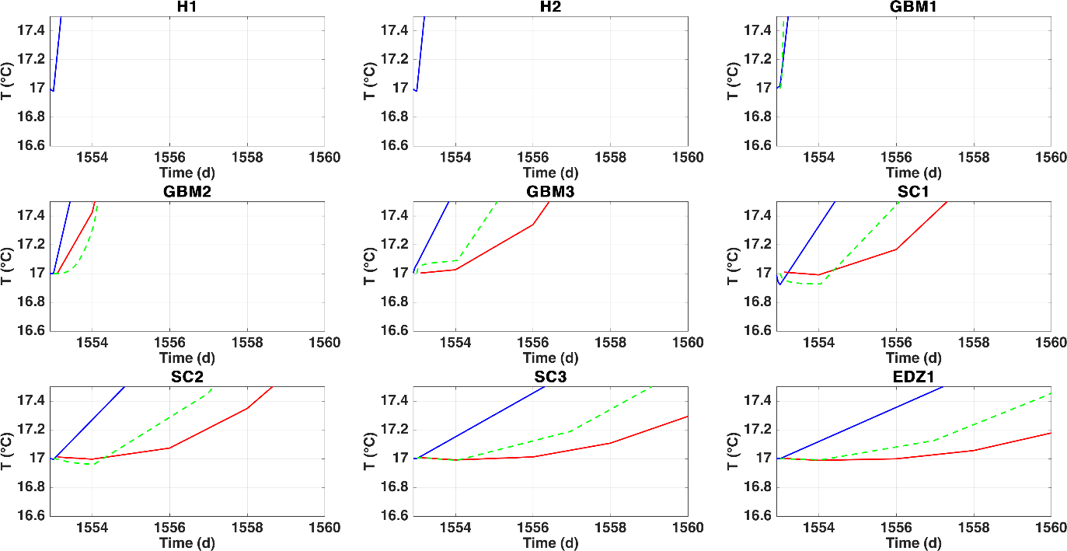

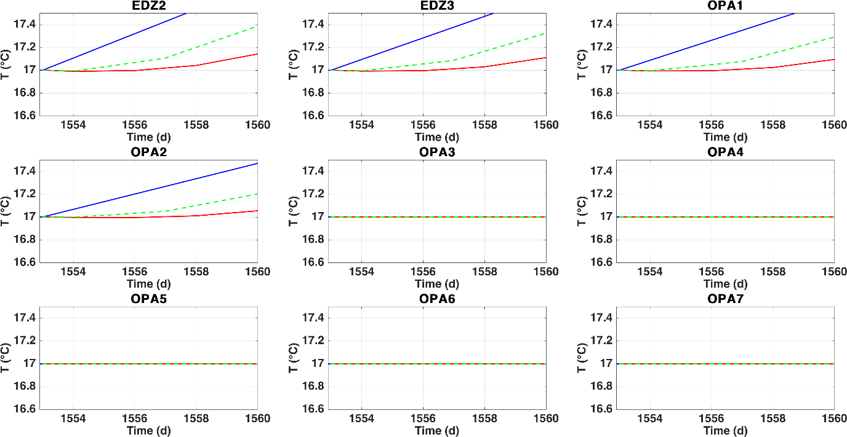

## Temporal evolution of temperature

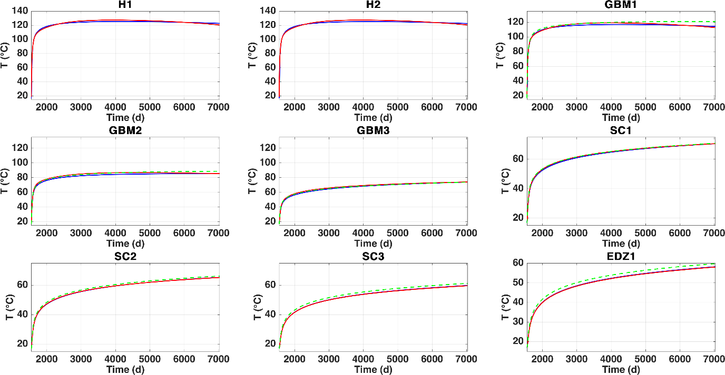

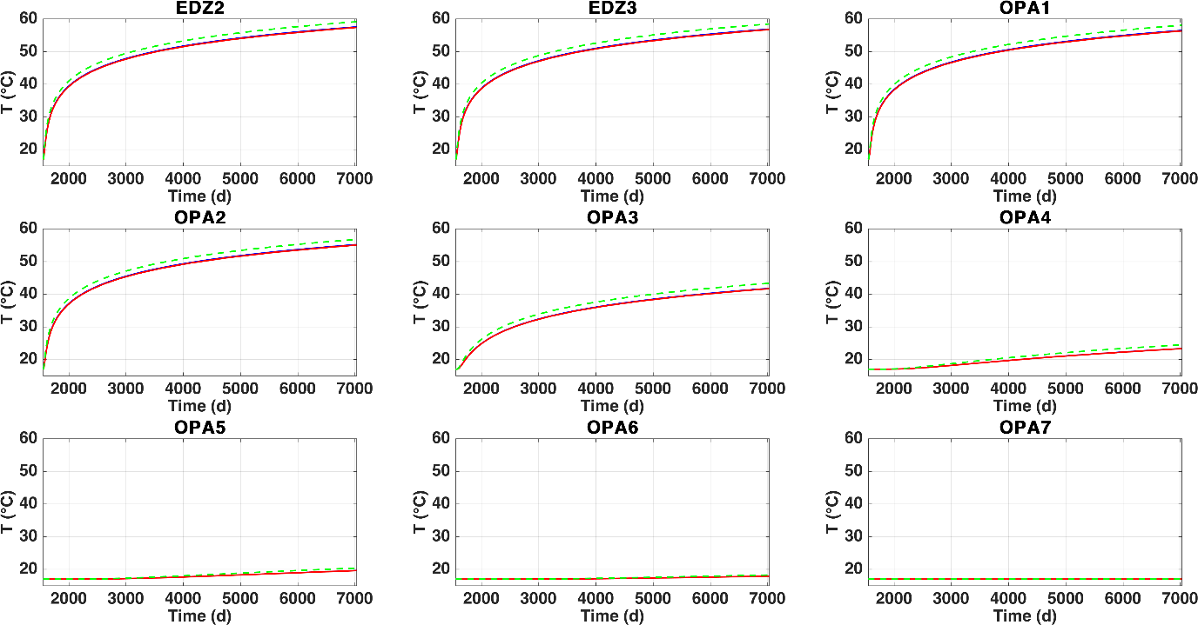

## Initial relative humidity

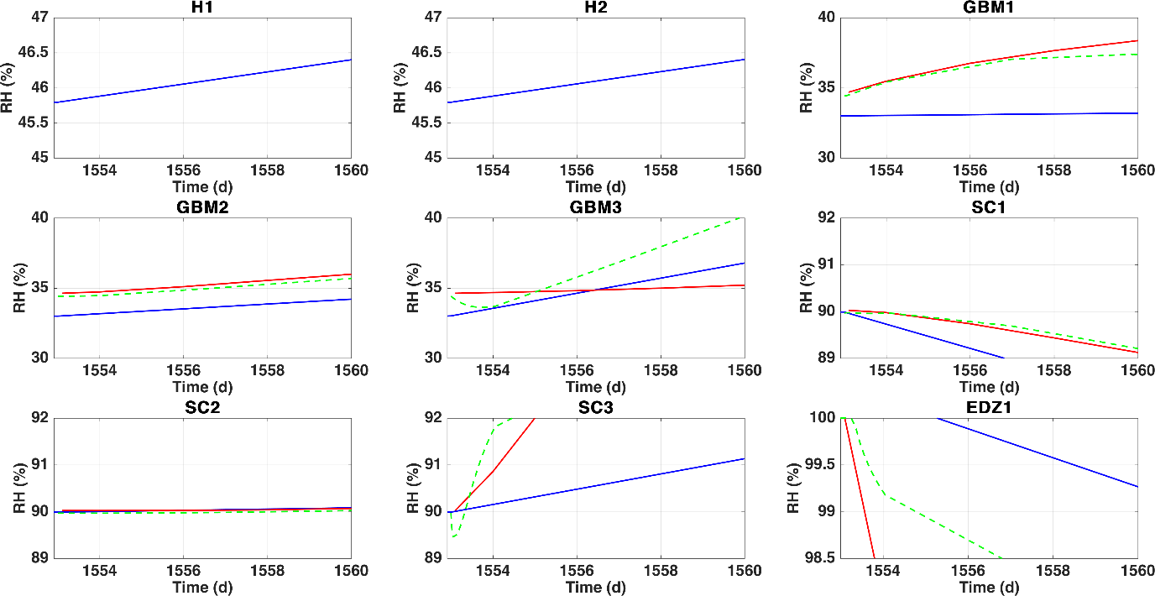

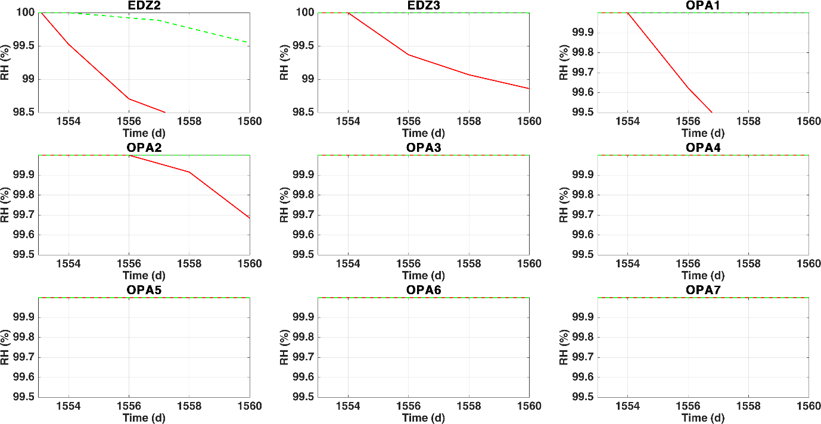

## Temporal evolution of RH

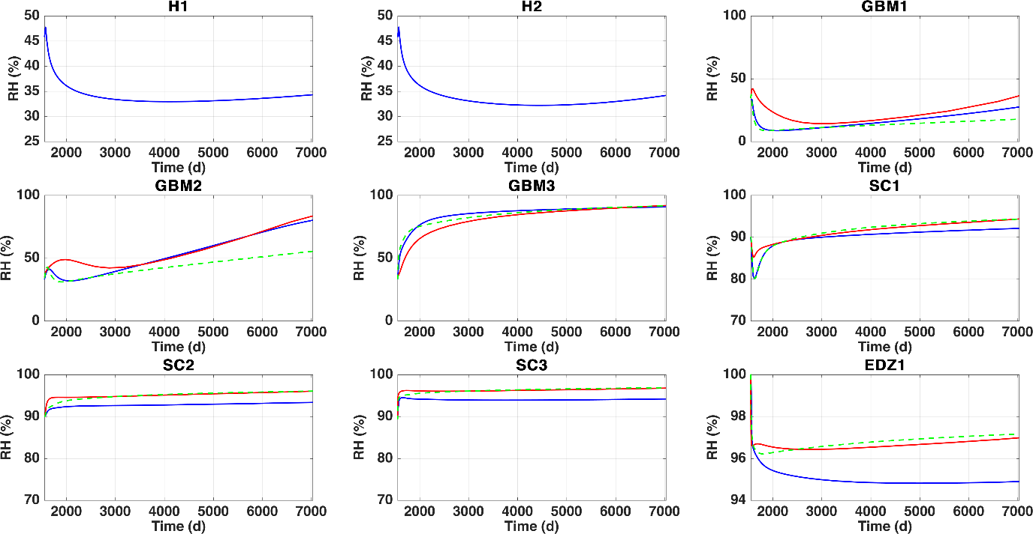

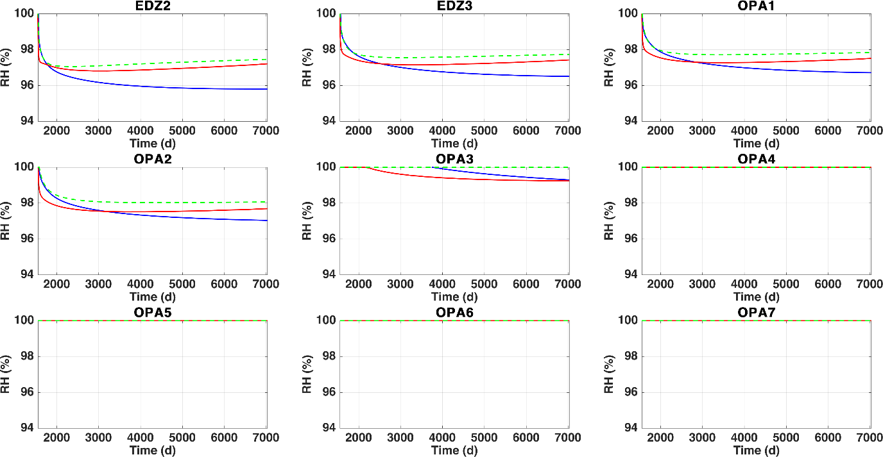

## Initial liquid pressure

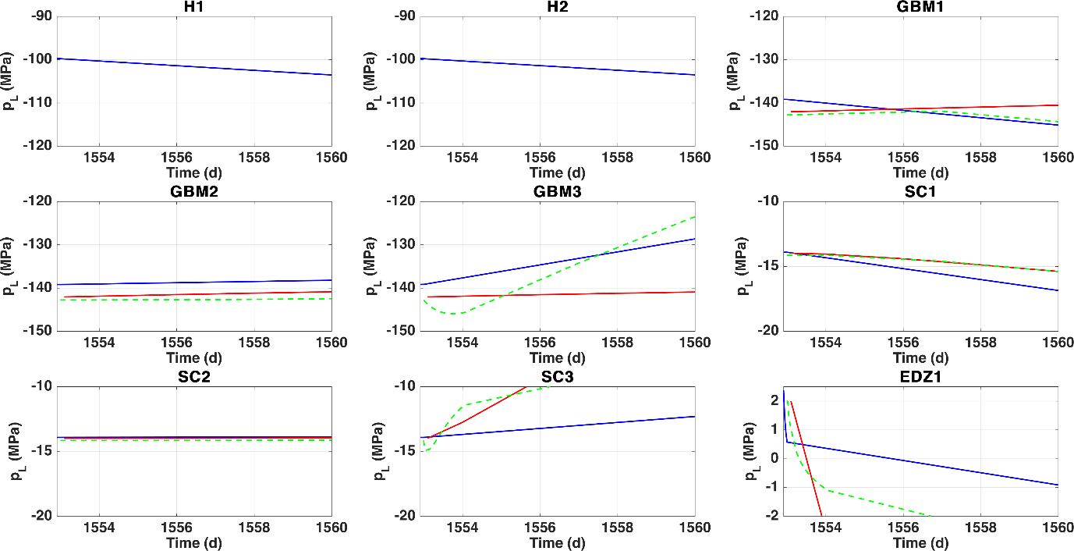

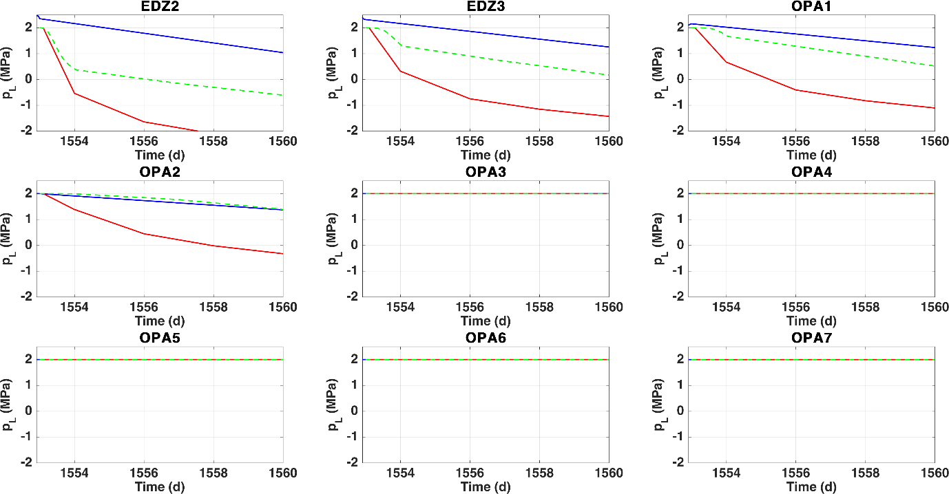

## Temporal evolution of pL

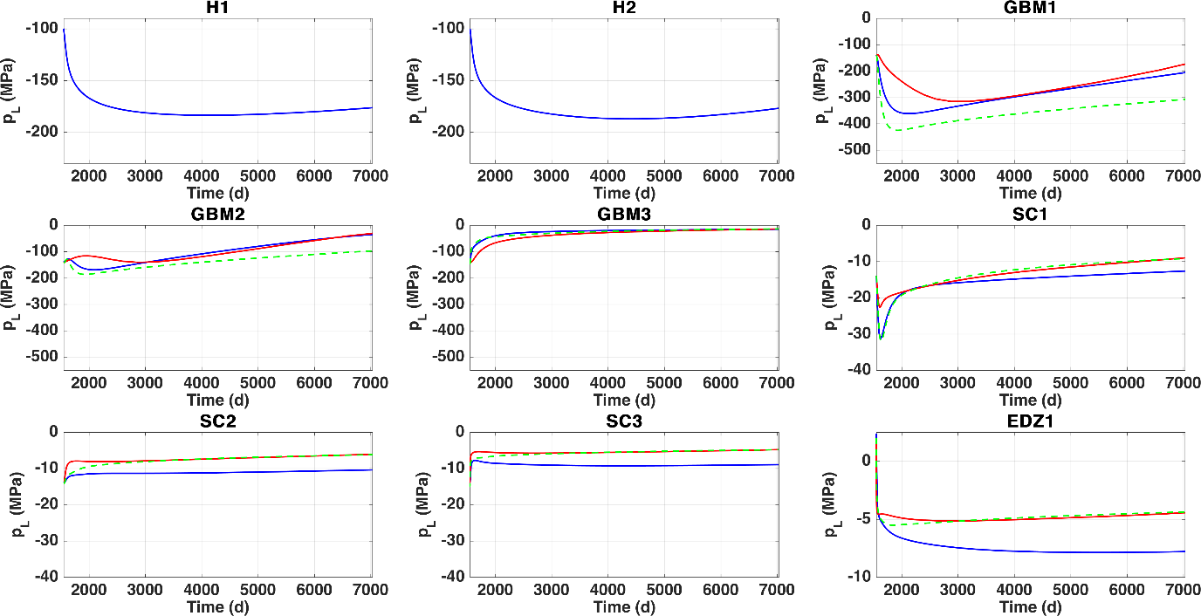

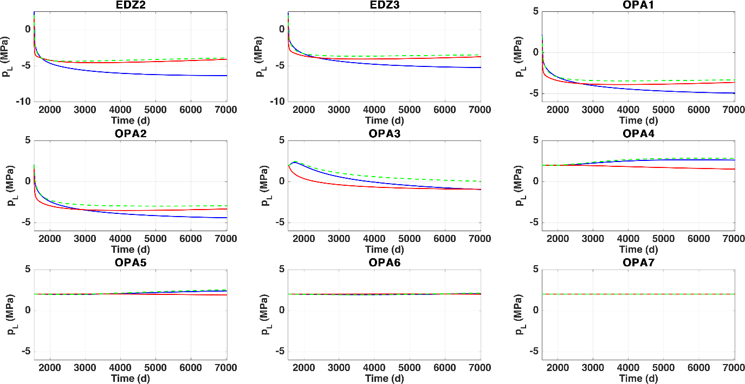

## Initial gas pressure (no results by OGS)

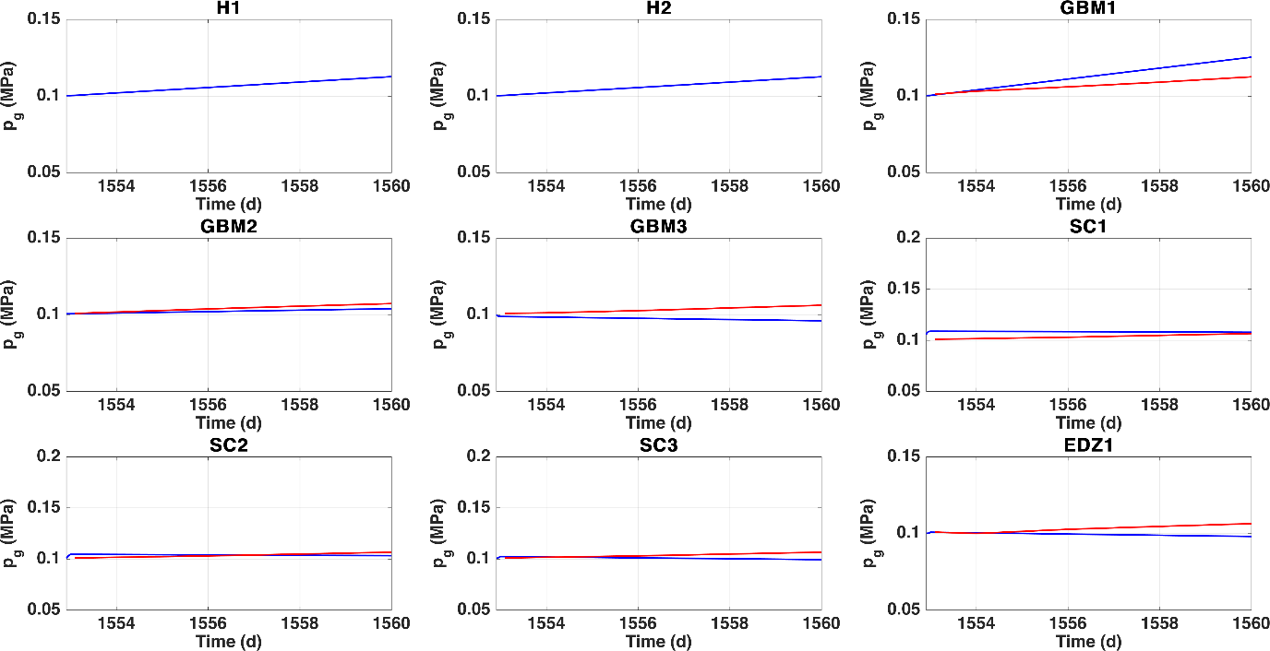

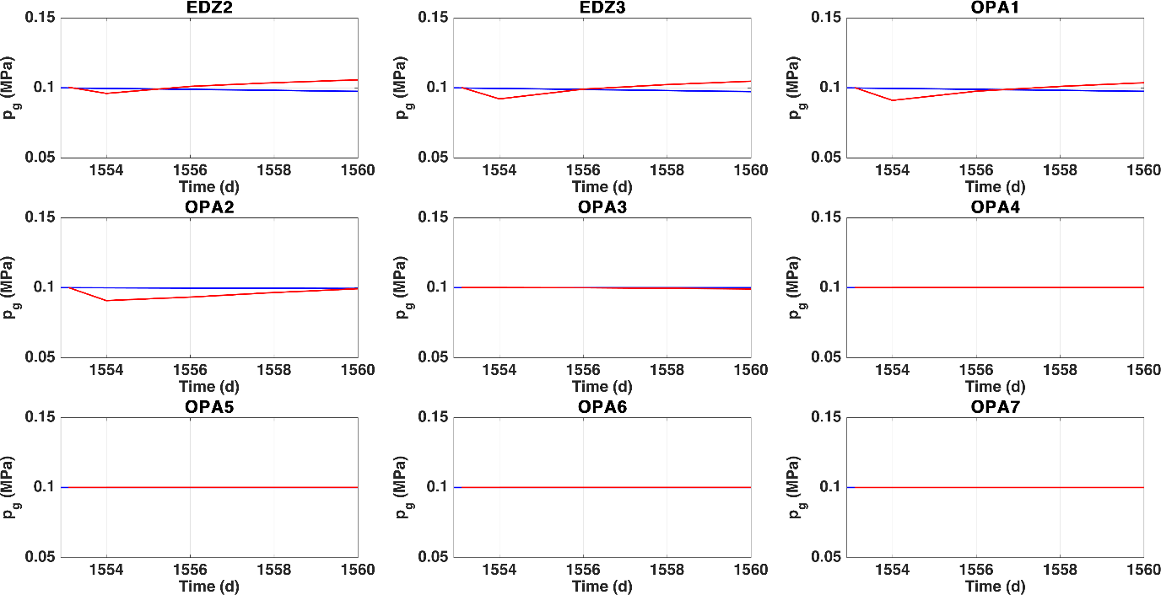

## Temporal evolution of pg

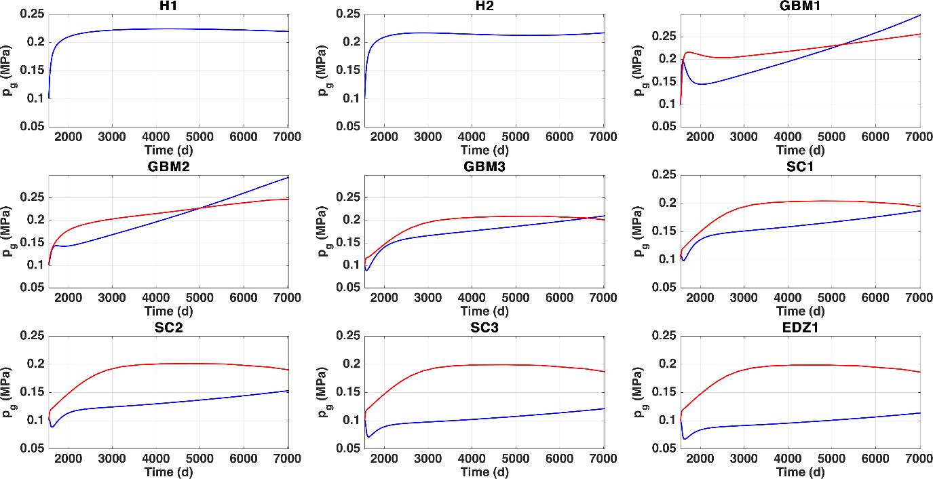

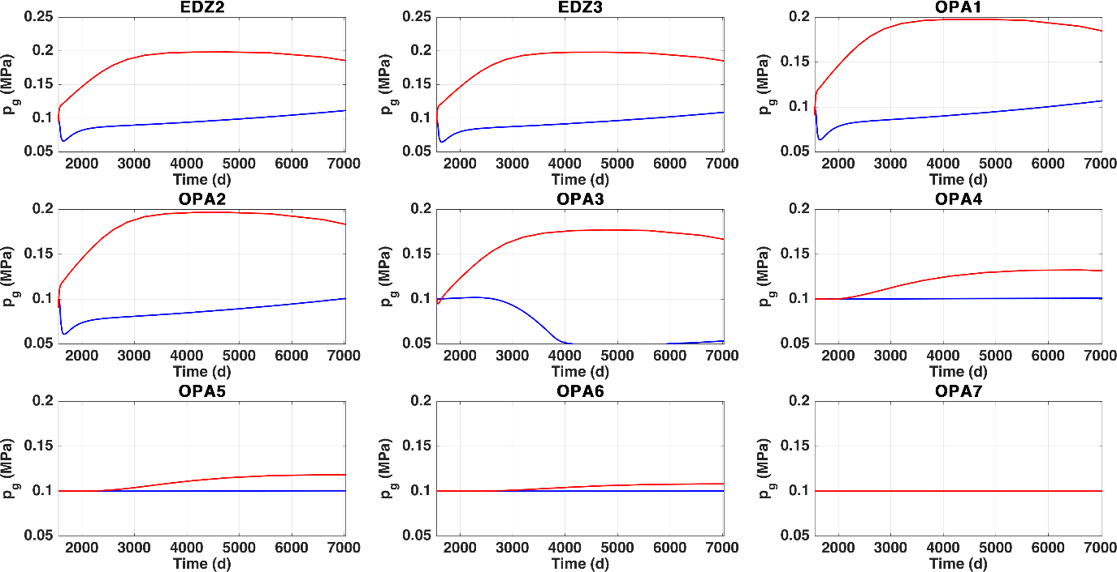

## Initial liquid saturation

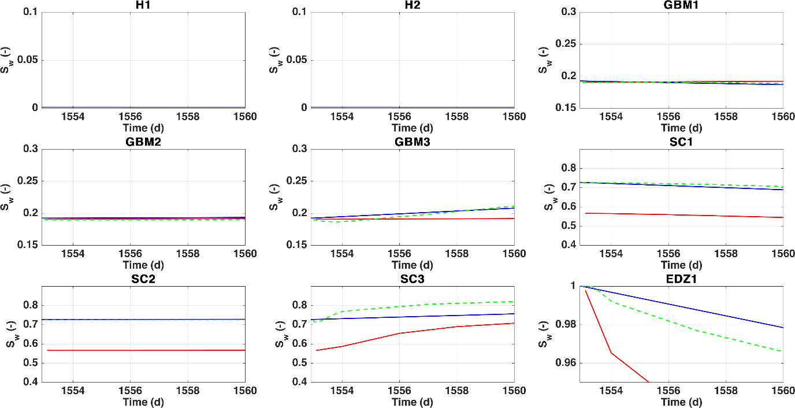

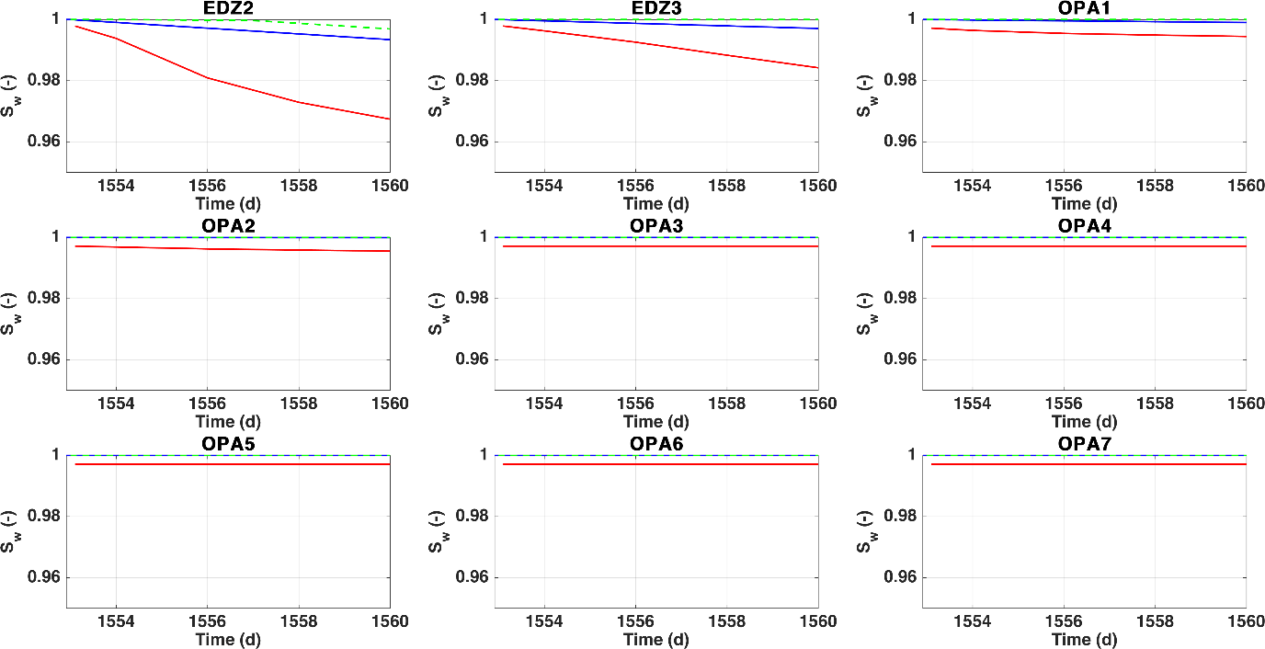

## Temporal evolution of liquid saturation

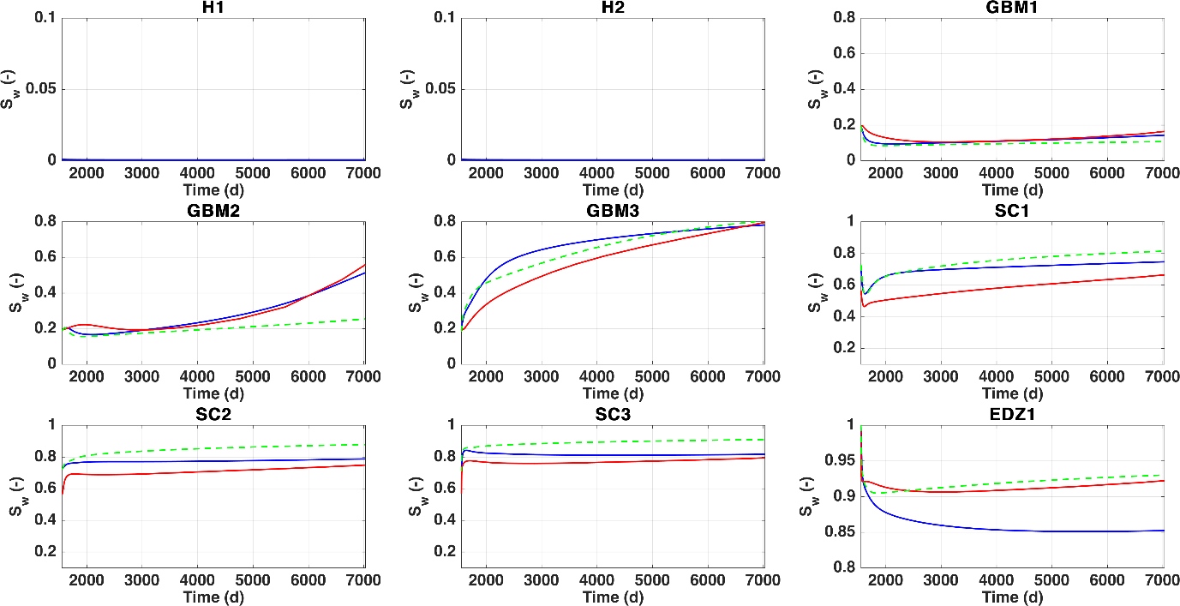

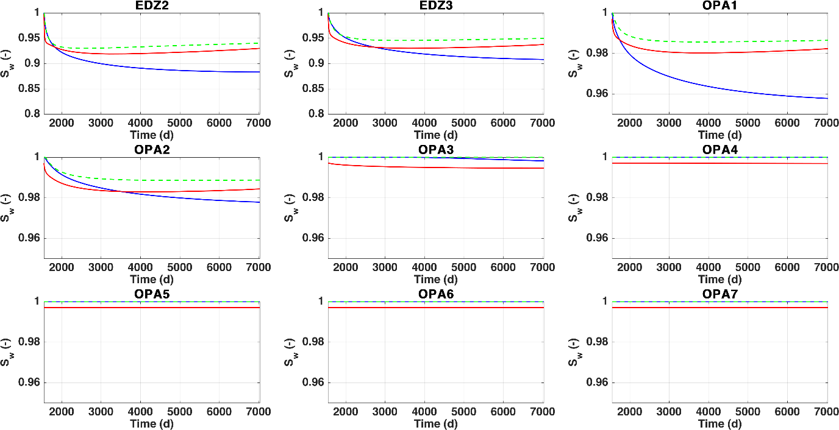

## Initial liquid density

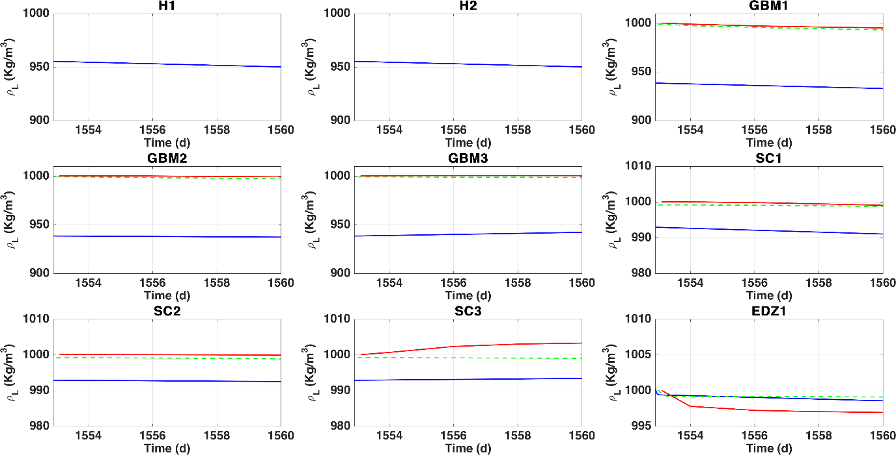

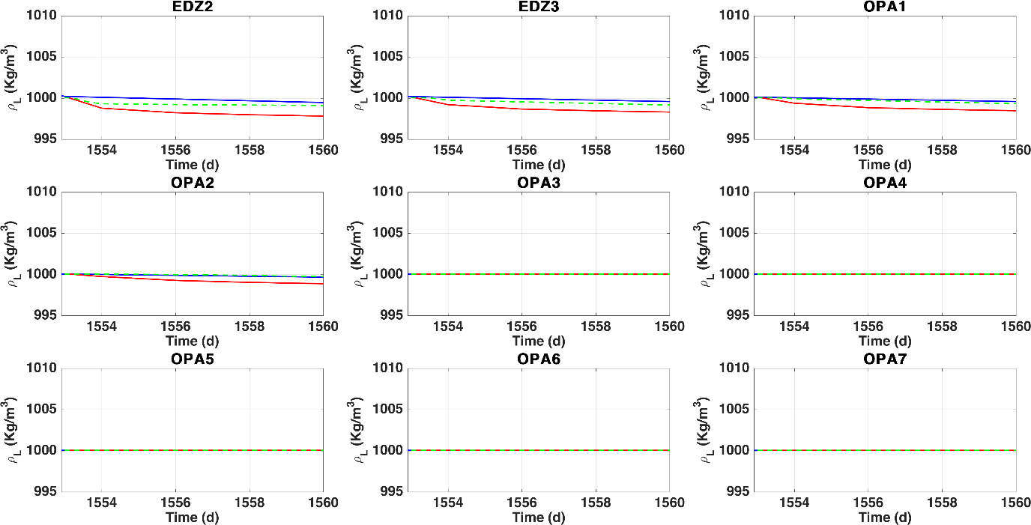

## Temporal evolution of liquid density

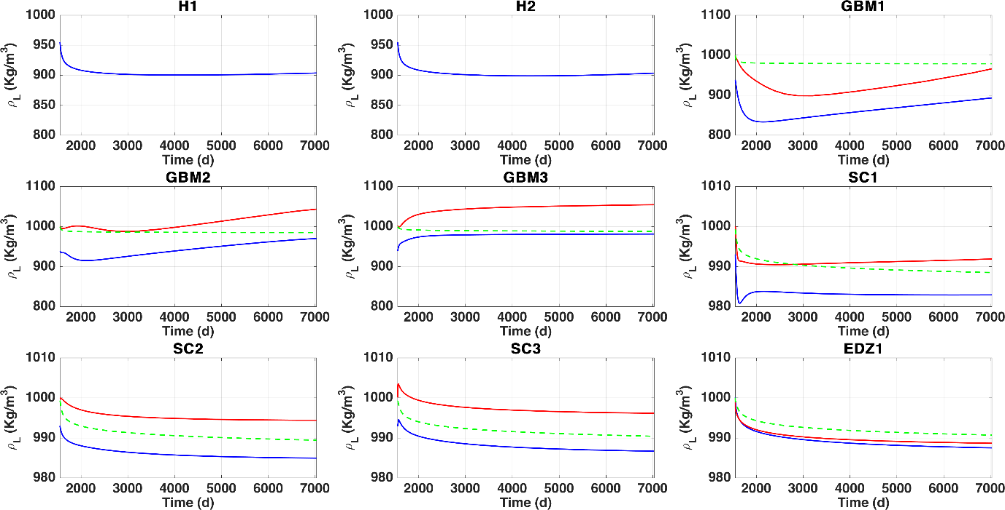

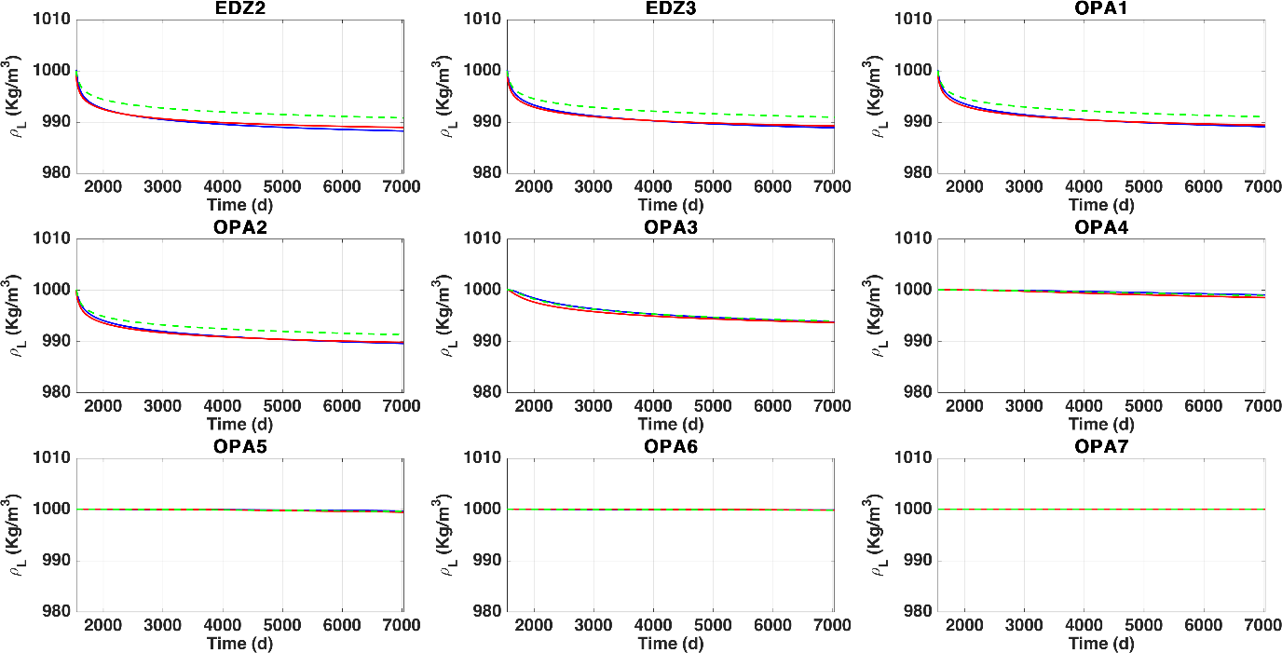

## Initial liquid viscosity

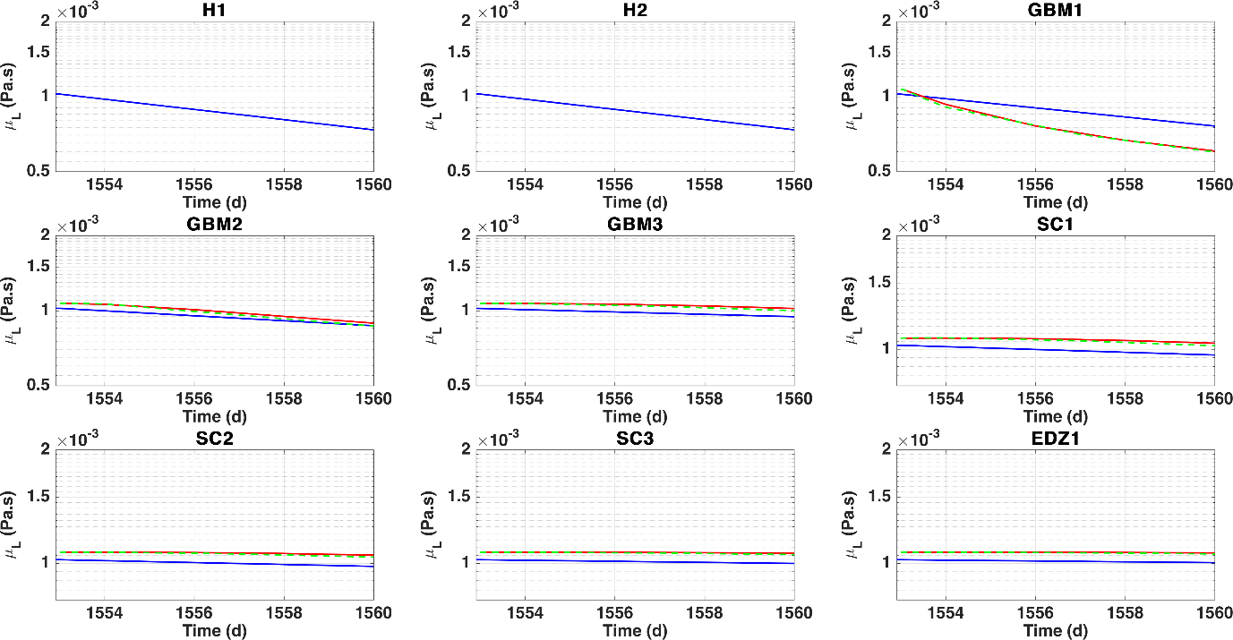

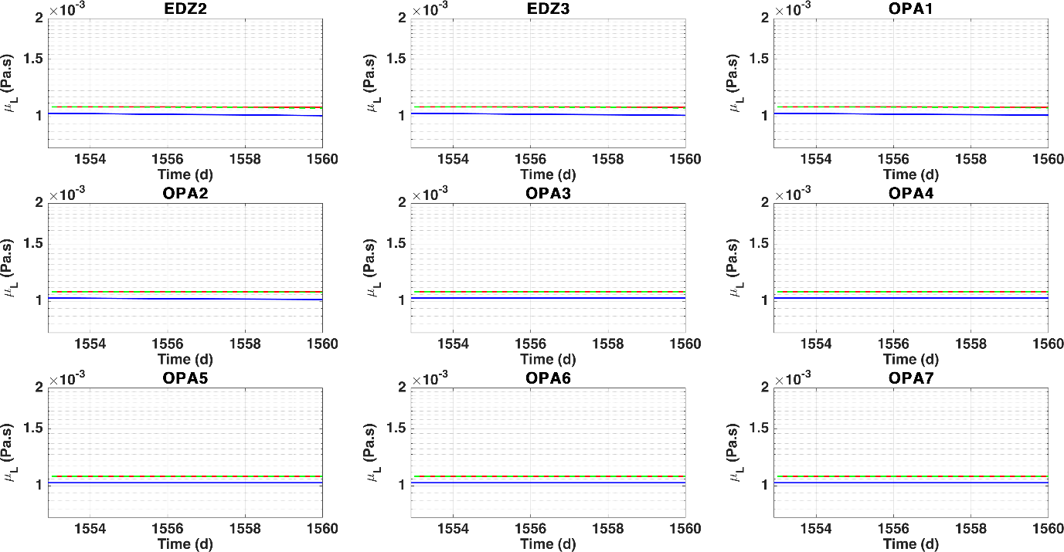

## Temporal evolution of liquid viscosity

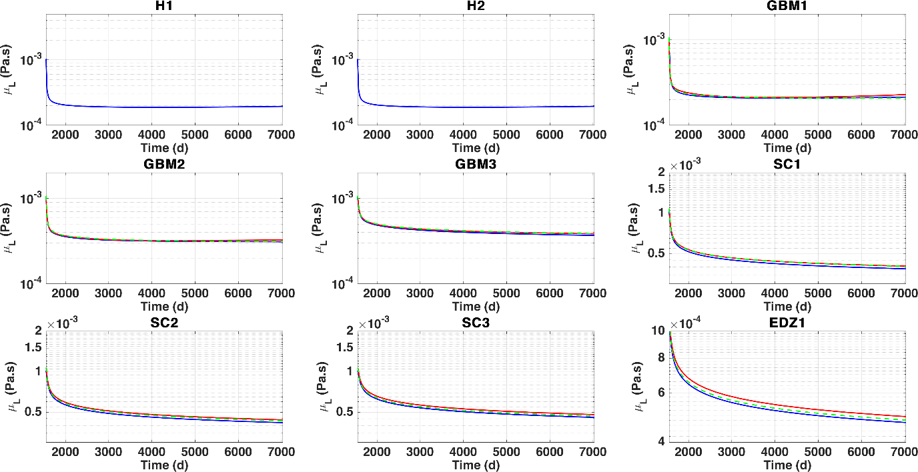

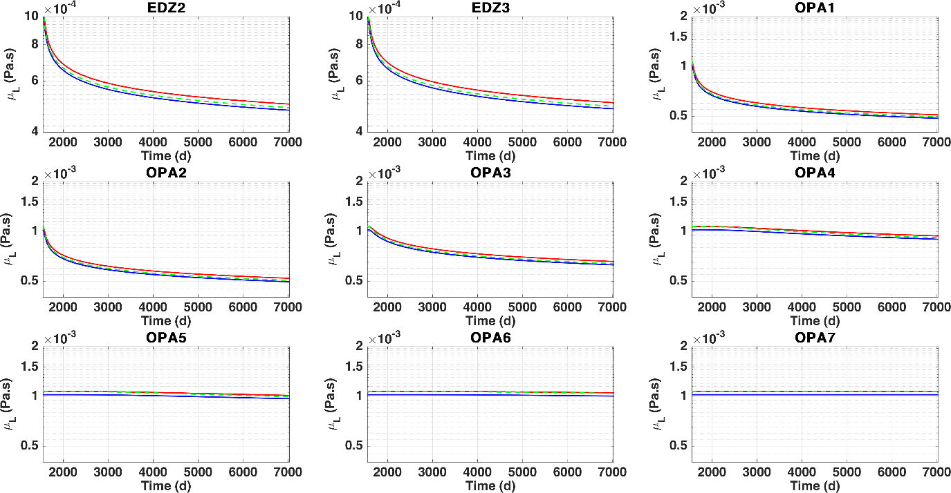

# Comparison water retention curves

CB and CA identical (used entry pressure 1 MPa), OGS differs in SC, perhaps used 10 MPa.

@OGS: Please verify that entry pressure is 1 and 10 MPa in models 9 and 10, respectively.

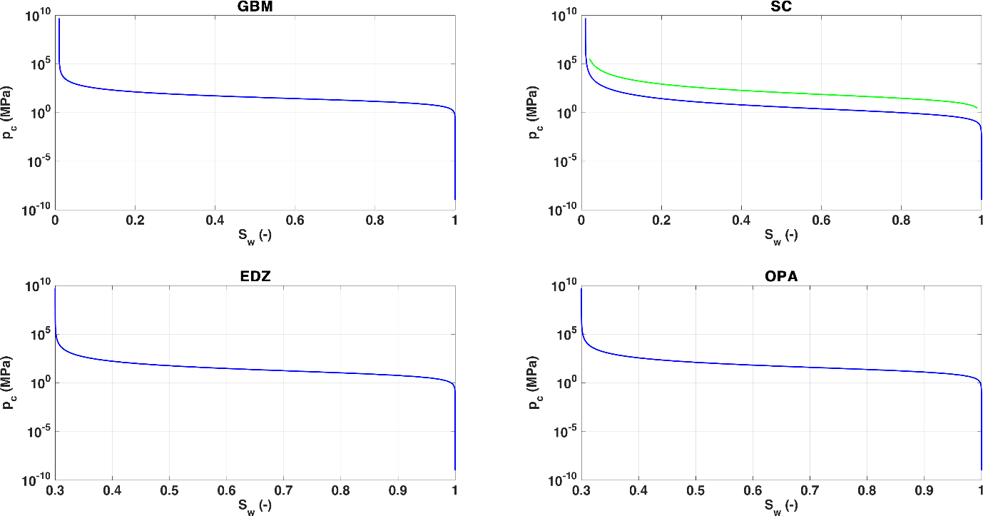

# Comparison liquid relative permeabilities

CB and CA identical. OGS systematically slightly underestimates krl. @OGS: please check implementation and/or supplied Excel.

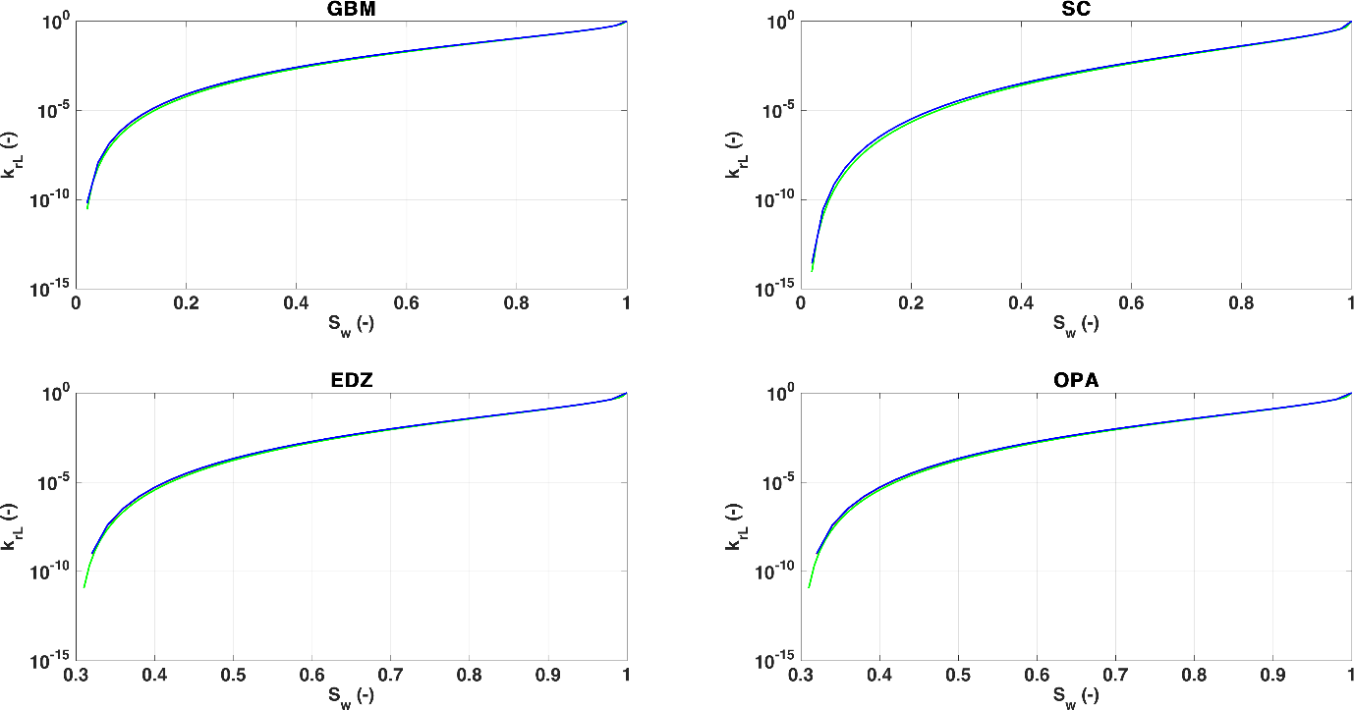

The following figure displays the ratio of krl calculated by OGS and CB/CA. For low saturation, it can be ten times smaller.

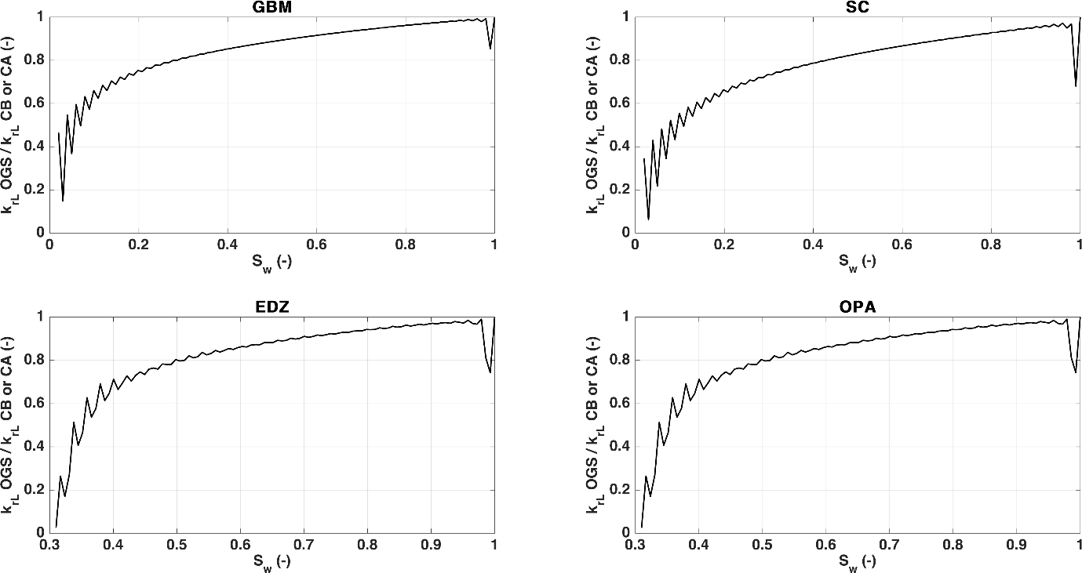

# Comparison gas relative permeabilities

Substantial differences CA-CB. I add my own calculation (dashed black line).

@UPC: please, check your krg.

@UPC: Apparently, you have provided in the Excel krg=Seg^3 (?). In Sebas email, it is understood that krg=1000*Seg^lambda (?). Please clarify. Eventually, a simulation with ITYCL=12 (modified van Genuchten could be provided.

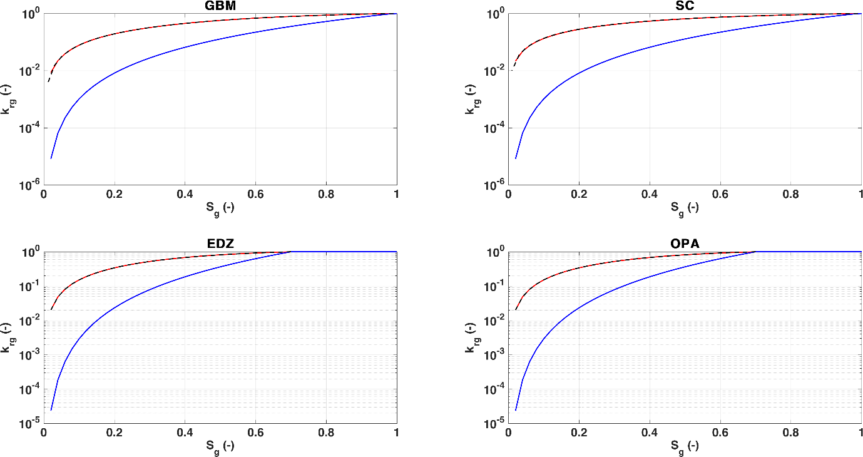

# Comparison thermal conductivity

Identical (the three curves are superimposed). Constant at EDZ and OPA.

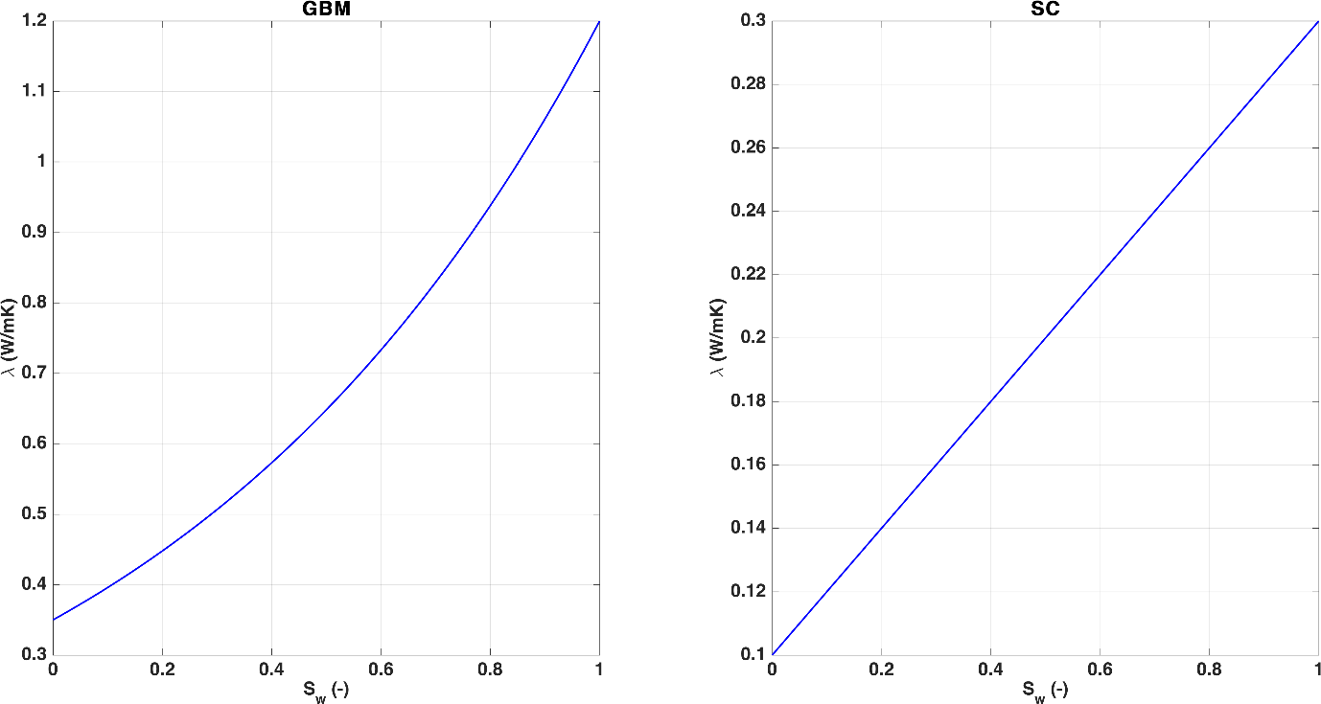

# Comparison diffusivity (no results OGS)

Apparently, CA and CB yield identical results in terms of effective diffusivity. No comparison possible in terms of diffusive flux.

@UPC/EPFL, please check the following parameters intervening in the diffusive flux (these ones are supplied by Matthias).

|  |  |  |
| --- | --- | --- |
|  | CA | CB |
| d0 | 5.90E-06 |  |
| n | 2.3 |  |
| Tau_opa | 0.8 |  |
| Tau_edz | 0.8 |  |
| Tau_shcr | 1 |  |
| Tau_gbm | 1 |  |
| poro_opa | 0.13 |  |
| poro_edz | 0.13 |  |
| poro_shcr | 0.331 |  |
| poro_gbm | 0.25 |  |
| Rgas | 8.3144 |  |
| Mvap | 0.018 |  |
| Mgas | 0.02896 |  |